Formula SAE – Chassis Design Report 2

Gustavo Ruiz – Chassis Team Lead, CAD Engineer
Brandon Guzman – Test Engineer, Engine box design
Alexandra Brister – Cockpit Engineer
Ryan Meger – Rear Suspension Box, Chassis Analysis
Carson Kent – Aerodynamic Engineer

Fall 2024-Spring 2025

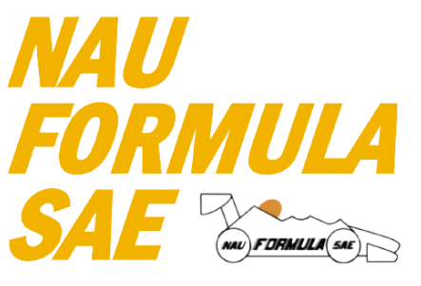

Project Sponsor: Northern Arizona University
Faculty Advisor: David Willy

DISCLAIMER
This report was prepared by students as part of a university course requirement. While considerable effort has been put into the project, it is not the work of licensed engineers and has not undergone the extensive verification that is common in the profession. The information, data, conclusions, and content of this report should not be relied on or utilized without thorough, independent testing and verification. University faculty members may have been associated with this project as advisors, sponsors, or course instructors, but as such they are not responsible for the accuracy of results or conclusions.

EXECUTIVE SUMMARY (Ryan Meger)
The Formula SAE chassis sub-team is tasked with the design and construction of the chassis for a Formula SAE style race car, with focuses on structural integrity, safety, integration, and overall performance. The chassis serves as the backbone of the car, supporting suspension, powertrain, driver and everything in between. The team’s primary objective is to create a lightweight, yet stiff frame that is compliant with the Formula SAE Rule Book, all while designing the cockpit to be comfortable, and pickup points and other aspects of the car to be widely adjustable, all while performing at a high level.
The chassis type chosen for NAU’s Formula SAE car was a steel space frame, mainly due to its adjustability when designing, but also cost. Primarily constructed from 4130 chromoly steel tubing, this material was used for its high yield strength, ease of fabrication and fantastic weldability. The design of the frame was influenced strongly by the rules in the Formula SAE rule book, such as triangulation of the steel tubes, roll cage parameters, side impact structure (SIS) design requirements.
Key design considerations as of now are weight minimization, driver ergonomics, suspension integration, and powertrain mounting. Reducing the weight of the chassis is a priority, while not compromising strength and stiffness. A force analysis study, done in SolidWorks and Ansys, was employed to quickly change designs and optimize the frame for both parameters mentioned above. Driver ergonomics were lacking luster from last year’s design. We aim to create more space in the cockpit by moving the front hoop forward and upwards, make the pedal box adjustable for different drivers, and keep the driver at a reasonable viewing angle. The suspension integration was done through extensive communication with the suspension sub-team. Making sure all mounting points were placed to ensure optimal load transfer during acceleration, braking, and cornering. All while making the body of the car integrate seamlessly with the suspension. The last design consideration was the powertrain mounting points. The chassis will have reinforced mounting points for the engine and transmission. Designing mounting points for high adjustability will allow for proper alignment, and weight distribution during high-performance operation.
Significant progress has been made on the chassis frame development and several deliverables have been met. The final chassis frame design has been reviewed and confirmed to comply with all applicable FSAE rules and regulations, this ensures that the frame meets the required safety, structural, and dimensional standards set forth by the competition. A full-scale PVC prototype of the chassis has been constructed to provide a physical representation of the final design allowing for verification of dimensions and customer requirements. The jig design, which is essential for accurate positioning and alignment during the chassis welding process has been fully completed. The Structural Equivalency Spreadsheet (SES) has been initiated with key data already being entered, this document ensures that the chassis structure adheres to FSAE’s safety and material standards. Lastly, the front and main hoops have been successfully bent according to the specified dimensions, these hoops will serve as the foundation for the rest of the chassis assembly. These accomplishments represent our team’s goals in the development of the chassis and show that we are on track to the completion of the final chassis design and manufacturing stages.

TABLE OF CONTENTS
Contents
DISCLAIMER 2
EXECUTIVE SUMMARY (Ryan Meger) 3
TABLE OF CONTENTS 4
1 BACKGROUND (Ryan Meger) 5
1.1 Project Description (Ryan Meger) 5
1.2 Deliverables (Brandon Guzman) 5
1.2.1 Course deliverables: 5
1.2.2 Client and competition specific deliverables: 2
1.2.3 Main Constraints for chassis: 2
1.3 Success Metrics (Ryan Meger) 2
2 Requirements (Ryan Meger) 4
2.1 Customer Requirements (CRs) (Ryan Meger) 5
2.2 Engineering Requirements (ERs)(Carson Kent) 6
2.3 House of Quality (HoQ) 10
3 Research Within Your Design Space 12
3.1 Benchmarking (Everyone) 12
3.1.1 Benchmarking – Side Impact Structure (Ryan Meger) 12
3.1.2 Benchmarking – Front, rear and main hoop concepts (Brandon Guzman) 15
3.2 Literature Review (Everyone) 18
3.2.1 Alexandra Brister – Seat Belt/ Seat/ Mounting System 18
3.2.2 Ryan Meger – Torsional Stiffness 19
3.2.3 Gustavo Ruiz – Chassis Frame Design 20
3.2.4 Brandon Guzman Benchmarking and Bending(b) 20
3.2.5 Carson Kent Aerodynamic Design 22
3.3 Mathematical Modeling (Everyone) 24
3.3.1 Seatbelt Stress/ Safety for 6-point and Seat Mounts– Alexandra Brister 24
3.3.2 Finite Element Analysis (FEA) of the Chassis – Ryan Meger 25
3.3.2.1 Torsional Analysis 25
3.3.2.2 Front and Side Impact Analysis 27
3.3.2.3 Bending mathematical modeling – Brandon Guzman 29
3.3.2.4 Preliminary Aerodynamics Mathematical Modeling – Carson Kent 31
4 Design Concepts 32
4.1 Functional Decomposition (Ryan Meger) 32
4.2 Process Diagram (Gustavo Ruiz) 34
4.3 Concept Generation (Everyone) 35
4.3.1 Chassis Generation Ryan Meger & Gustavo Ruiz 35
4.3.2 Seat Belt Systems – Alexandra Brister 36
4.4 Selection Criteria 38
4.4.1 Chassis Selection Criteria – Gustavo Ruiz 38
4.5 Concept Selection 39
4.5.1 Concept Selection for Chassis Design (Ryan Meger) 39
5 SCHEDULE & BUDGET (Gustavo) 40
5.1 Schedule 40
5.2 Budget 41
5.3 Bill of Materials for JIG (BOM) 42
6 DESIGN VALIDATION & INITIAL PROTOTYPING 43
6.1 Failure Modes & Effects Analysis (FMEA) 43
6.2 Initial Prototyping 44
6.3 Other Engineering Calculations 55
6.4 Future Testing Potential 57
7 REFERENCES 59
7.1 Alexandra Brister 59
7.2 Ryan Meger 59
7.3 Brandon Guzman 60
7.4 Gustavo Ruiz 61
7.5 Carson Kent 62
8 APPENDICES 64
8.1 Appendix A: FSAE Rules 64
8.2 Appendix B: House of Quality 64
8.3 Appendix C: FMEA 65

BACKGROUND (Ryan Meger)
The first chapter will be used to introduce the goals and requirements of the Formula SAE capstone project. This includes the requirements given by the Formula SAE rulebook, and team goals. The NAU Mechanical Engineering school is setting ambitious yet tangible goals and objectives as a second-year team to create a standard for future Formula SAE teams.

Project Description (Ryan Meger)
The Formula SAE project described by SAE International is “The Formula SAE competitions challenge teams of university undergraduate and graduate students to conceive, design, fabricate, develop and compete with small, formula style vehicles. The competition is an engineering education competition that requires performance demonstration of vehicles in a series of events, both off track and on track against the clock. Each competition gives teams the chance to demonstrate their creativity and engineering skills in comparison to teams from other universities around the world.” As a second-year team, we are striving to exceed last year’s performance and fix any issues that arose during design, manufacturing and testing. Building a base for future teams to be successful.
As described above by SAE International, the project gives students the opportunity to put all their engineering knowledge gained into practice. Allowing students to expand their connections with other students, faculty, and potential employers. It also connects the teachings from past engineering courses to develop an engineering design process that will end with a successful capstone project. With the nature of the Formula SAE project, hands on skills in the machine shop will also be developed. Creating and refining real-world knowledge on manufacturing.
The chassis team’s total budget for the Formula 2025 car project is $6,058.24. To date, $1,747.99 has been spent on all the tubing, jig materials, and the PVC prototype, leaving $4,310.25 for future expenses. We plan to secure a sponsorship from Nova Kinetics, which will cover the cost of our first aerodynamic component, the front nose cone, which will help reduce the overall project expenses. Our primary fundraising efforts are focused on obtaining donations from individuals to support the team, while also exploring potential sponsorships to further offset expenses.

Deliverables (Brandon Guzman)

Course deliverables:
The project scope for this course is to design and manufacture a new FSAE chassis for the 2025 racing season. The sub-team has been given the task of iterating on the 2024 FSAE chassis design which was also the first year NAU competed in this competition. Main goals include:
- Conform to all FSAE chassis rules
- Improve on the previous year senior designs
- Manufacture components for final design
- Document manufacturing process for future senior designs.
In addition to these major goals, the chassis design plays a large role in impacting the other systems and sub-team designs. To achieve the most efficient design, the team aims to be as flexible as possible to consider the needs of each subsystem for the car.

Client and competition specific deliverables:
The client and competition specific deliverables for this project were determined after a thorough review of the rules and research in each iteration of the chassis design. These deliverables can be summed into a brief list of constraints that will reinforce decisions with chassis designs and iterations.

Main Constraints for chassis:
- Tubing specifications: Tubing requirements are based on application are defined in section F.3.2 of the 2025 FSAE Rules. This involves thickness and tube diameter.
- Roll Hoop dimensions: The main and front hoop design are to comply with rules in sections F.5.6—F.5.9. Which defines clearance for safety based on the 95th percentile male as well as protection in case of rollover.
- Cockpit: Cockpit dimensions must comply with section T.1. this is a requirement for the competition. The driver must be able to safely and quickly exit the vehicle through the Egress test which is defined in section IN.5 which is also a requirement for the competition. Both sections can be found in the 2025 FSAE Rule Book.
- Driver Template Position: Bottom 200 mm circle on seat bottom where the distance between the center of this circle and the rearmost face of the pedals is no less than 915 mm. The driver template is important to ensure that rules and regulations are met while applying our customer requirements.
All of these sections will be linked in Appendix A at the end of this report, any other constraints or competition specific deliverables will be defined in section 2.1 and 2.2 regarding Customer and Engineering requirements.

Success Metrics (Ryan Meger)
The success metrics for the Formula SAE project will be measured by categories as laid out by the SAE Design Judging Score Card. The four categories are based of the car’s design, build, refinement/validation, and understanding. Having an innovate design that push the limits of the rule book and performance of the vehicle is an interest point the judges will be investigating. As a second team year, we are focusing on completing all dynamic events and static tests while having a safe car and performing at a high level.
Success of the project means completing all dynamic events and static tests, while passing inspection done by the judges at the SAE International this coming May. The dynamic tests are performance tests on the car, which include acceleration, skid pad, autocross, efficiency, and endurance events. The Static tests include a leak test, and a knowledge test of the car and the design choices. The primary goal of the project is to have a car that goes to competition, passes technical inspection, and competes in all dynamic events at a higher level than last year. As last year’s car didn’t complete all the events, we want to make a name for NAU’s mechanical engineering school as a high-level competitor.

Requirements (Ryan Meger)
When building an FSAE car the most important requirements would be to build a high performance, durable racecar that can compete against the rest of the field. Along with this there are numerous underlying requirements which help us succeed in building a successful design. There are several sections which these requirements are divided into including general regulations, administrative regulations, chassis and structural, technical aspects, and driver equipment. All of the regulations and requirements will be discussed in the section following.

Customer Requirements (CRs) (Ryan Meger)
The customer requirements for the chassis were taken from the rules specified in the Formula SAE rulebook for 2024 and improvements from last year’s car. These requirements are specifications and functions that the chassis must perform to pass the technical inspection. The customer requirements are as follows.
The cockpit of last year’s car was cramped, not allowing the driver to use the car to its full extent. Changing the design of the cockpit to make it larger is a priority in our chassis design this year.
The primary structure must meet the specified requirements for each section of the chassis. The rules split the tubing sizes into size A, B, and C, with the specified dimensions for each size. Tube sizes must meet the standards for each section of the chassis, laid out in the FSAE rulebook.
Another improvement the team would like to achieve on this year’s design is a removeable firewall. The fire wall is in proximity to the powertrain system so having it be removeable will allow for maintenance and adjustability of the engine to be efficient and effective.
Aerodynamics attached to the car have also been considered for this year’s car. Having aero will give the car more of a fighting chance against the other school we are competing with. The body of the car and other aero attachments must seamlessly integrate on the chassis. Making it easy to remove and assemble.
The pedal box is required to fit three pedals. Making sure the area for the pedal box is large enough to house the new pedal box design.
Reduce Rear Suspension Z-axis size?
The car must use a 5-, 6-, or 7-point harness and meet one of the following: SFI Specification 16.1, SFI Specification 16.5, or FIA Specification 8853/2016. Also, the lap belt must pass around the pelvic area below the anterior superior Iliac Spines.
The front bulkhead must be securely integrated into the frame. This creates a protection bubble around the driver’s legs in between the front hoop and front bulkhead area.
The fuel tank is a potential safety hazard for the driver. Having it shielded from side and rear impacts is paramount to the safety of the driver.
To meet rule book requirements regarding aero, the front aero must be no more than 700mm forward of the front tire. The aero in the back must be no more than 250mm rearward of the rear tire.
The SIS is required to connect the front and main hoops, creating a stiff design and give the driver a bubble of protection.
The cockpit must accommodate the driver template, designed by FSAE. This gives the cockpit is the correct dimensions to accommodate a driver up to the size of a 95th percentile male.
Meeting deliverables is important for the success of the car, so prioritizing the ease of manufacturing the chassis is important to the team.

Engineering Requirements (ERs)(Carson Kent)
Vehicle Configuration
The engineering requirements along with the customer requirements are derived directly from the FSAE rulebook. The requirements listed below are the technical requirements that we must accomplish to not only build a high performing car but more importantly to be able to compete. The engineering requirements are listed below in categories.
Since the vehicle must be open wheeled, the top 180 degrees of the wheels/tires must be unobstructed when viewed from above and from the side of the wheels. (see figure 1)
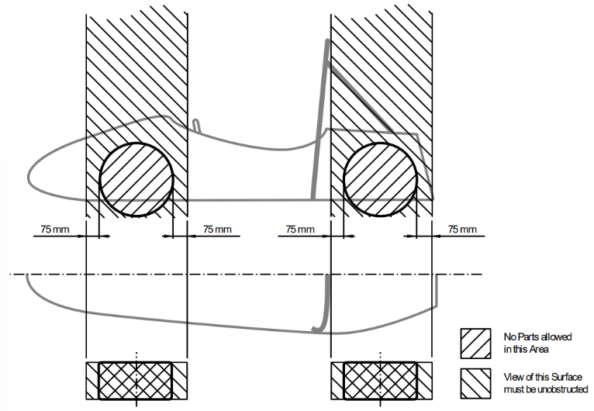
Figure 1: Open Wheel Requirements
The vehicle must have a minimum wheelbase of 1525 mm, and the track and center of gravity must combine to provide sufficient rollover stability.
The smaller track of the vehicle must be no less than 75% of the larger track.
Ground Clearance
Ground clearance must be sufficient to prevent any portion of the vehicle except the tires from touching the ground during dynamic events.
The distance to the ground below the Lower Side Impact Structure at its lowest point must be 90 mm or less. The distance to the ground should be 75 mm or less. There must also be an opening for measuring the ride height at that point without removing aerodynamic devices.
Intentional or excessive ground contact of any portion of the vehicle other than the tires will forfeit a run or event.
Driver
The vehicle must be able to accommodate drivers of sizes ranging from 5th percentile female to 95th percentile male.
The driver's head and hands must not contact the ground in any rollover attitude.
The driver must have sufficient visibility to the front and sides of the vehicle.
In a normal seating position, the driver must have a minimum field of vision of 100 degrees to the left and right sides.
Chassis
The fabricated structural assembly that supports all functional vehicle systems. This assembly may be a single fabricated structure, multiple fabricated structures or a combination of composite and welded structures.
The minimum radius of any bend, measured at the tube centerline, must be three or more times the tube outside diameter.
Frame members
A minimum representative single piece of uncut, continuous tubing.
Monocoque
A type of chassis where loads are supported by external panels.
Main hoop
A roll bar located alongside or immediately aft of the driver’s torso.
Front hoop
A roll bar located above the driver’s legs, in proximity to the steering wheel.
Roll hoop
Referring to the front hoop and the main hoop.
Roll hoop bracing supports
The structure from the lower end of the roll hoop bracing back to the roll hoop(s).
Front bulkhead
A planar structure that provides protection for the driver’s feet.
Impact Attenuator
A deformable, energy absorbing device located forward of the front bulkhead.
Primary Structure
The combination of these components:
- Front bulkhead and front bulkhead support
- Front hoop, main hoop, roll hoop braces and supports
- Side impact structure
- Any frame members, guides, or supports that transfer load from the driver restraint system
Primary structure envelope
A volume enclosed by multiple tangent planes, each of which follows the exact outline of the primary structure frame members.
Major Structure
The portion of the chassis that lies inside the primary structure envelope, excluding the main hoop bracing and the portion of the main hoop above a horizontal plane located at the top of the upper side impact member or top of the side impact zone.
Rollover protection envelope
The primary structure plus a plane from the top of the main hoop to the top of the front hoop, plus a plane from the top of the main hoop to the rearmost triangulated structural tube, or monocoque equivalent.
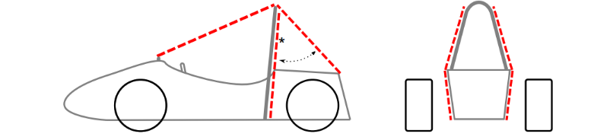
Figure 2: Rollover Protection Envelope
Tire surface envelope
The volume enclosed by tangent lines between the main hoop and the outside edge of each of the four tires.
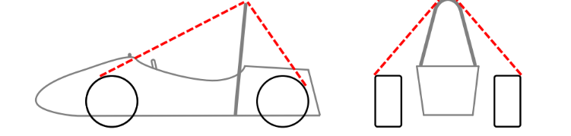
Figure 3: Tire Surface Envelope
Component envelope
The area that is inside a plane from the top of the main hoop to the top of the front bulkhead, plus a plane from the top of the main hoop to the rearmost triangulated structural tube, or monocoque equivalent.
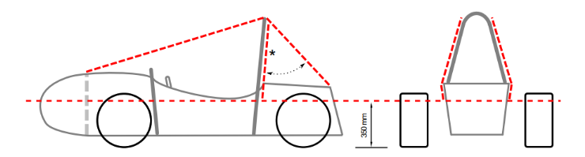
Figure 4: Component Envelope
Buckling modulus
Equal to E*I, where E = modulus of elasticity and I = area moment of inertia about the weakest axis.
Triangulation
An arrangement of frame members where all members and segments of members between bends or nodes with structural tubes form a structure composed entirely of triangles.
- This is generally required between an upper member and a lower member; each may have multiple segments requiring a diagonal to form multiple triangles.
- This is also what is meant by “properly triangulated”

Figure 5: Triangulation Requirement

House of Quality (HoQ)
The house of quality QFD can be found in Appendix (Letter). Since our customer requirements are pulled from the rule book, the engineering requirements correlate with the customer requirements, meaning the customer requirements must be met to pass technical inspection. The engineering requirements describes how to customer requirements will be fulfilled. Due to the nature of passing technical inspection the customer requirements were all weighted with 5, the highest possible. When looking at the engineering requirements a majority of them are in regard to the main hoop. This result makes sense since the main hoop provides the highest level of protection for the driver if a roll over occurs. The chassis must meet tangible and important requirements in order to pass technical inspection, meaning all the customer and engineering requirements must be met to pass. Having a ranking system of importance regarding the chassis is unnecessary. To be repetitive and assertive in this statement, all requirements must be met.
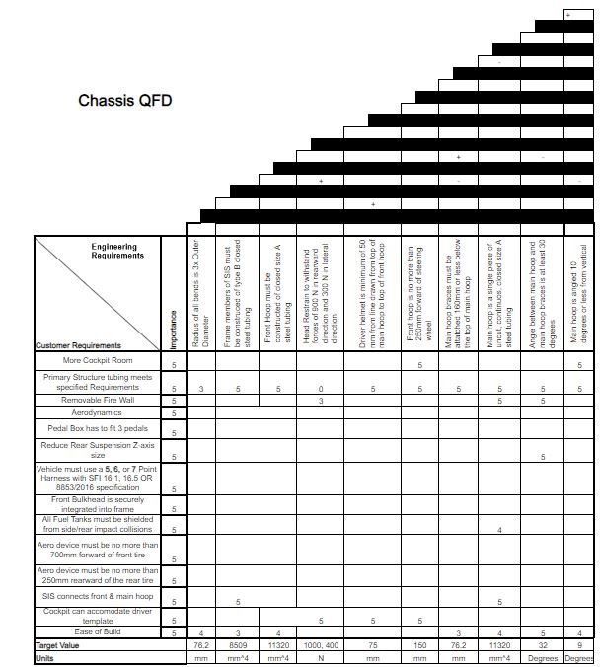

Research Within Your Design Space

Benchmarking (Everyone)

Benchmarking – Side Impact Structure (Ryan Meger)
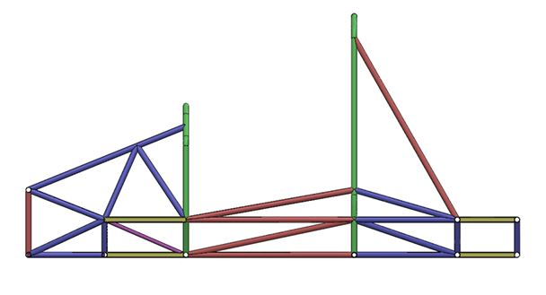
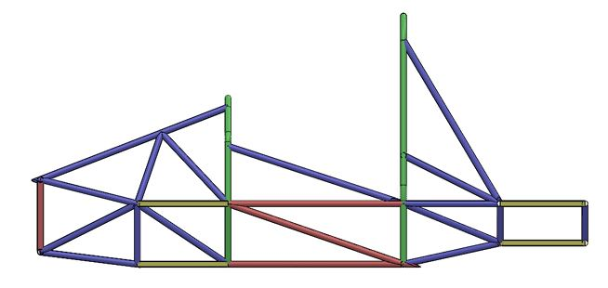
Conducting research on universities Formula teams, University of Arkansas had an extensive review of seven different iterations. The first iteration had SIS tubes running backwards up towards the main hoop, providing support for the main hoop. It did leave a large amount of area towards the front hoop that could be dangerous in a collision. Iteration 2 added more SIS structure to deal with that concern and increased torsional rigidity by 58%. Farther down the iterations, iteration 6, they reduced the size of the top SIS tube, to reduce weight. Their final iteration surpassed their goal of 1750 ft-lb/deg(2372.7 Nm/deg) by 13ft-lb/deg.
Figure 6: University of Arkansas V.1

Figure 7: University of Arkansas V.2

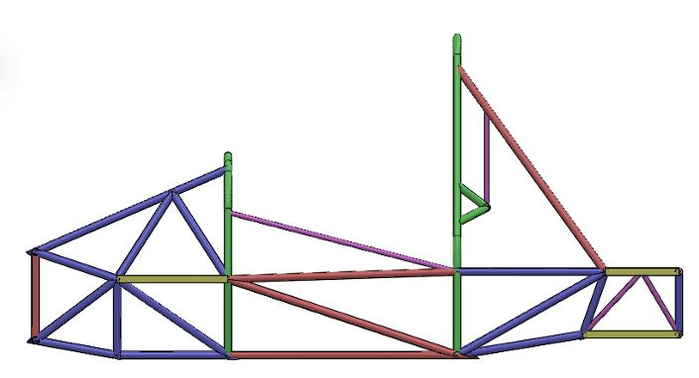
Figure 8: University of Arkansas V.3

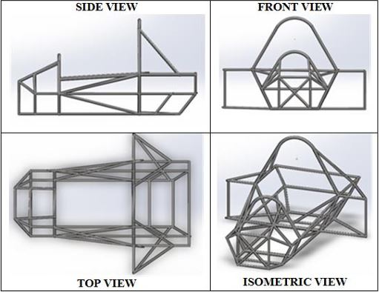
The next source is from the University of Bhopal, India. Their frame design took an unorthodox approach by adding structural side pods. This increased torsional rigidity and protection from side impacts. The structural side pods were highly effective at protecting the driver in their analysis but added a large amount of weight to the chassis.
Figure 9: University of Bhopal Chassis Design

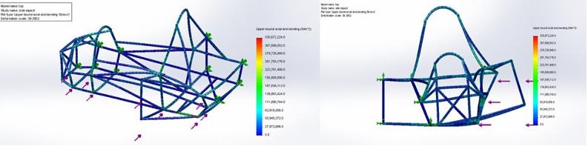
Figure 10 7: University of Bhopal SIS Analysis
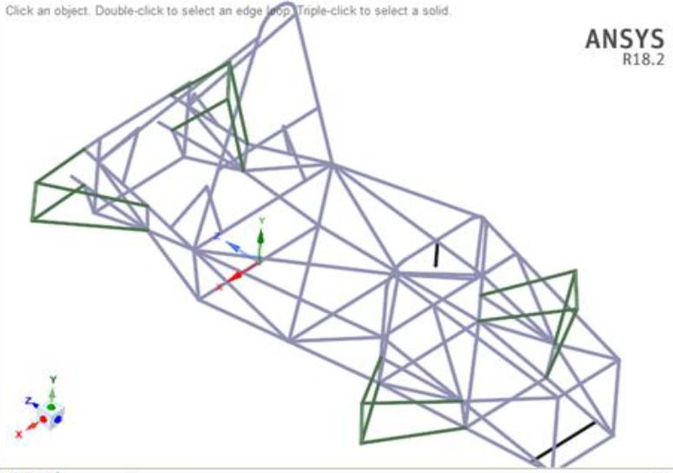
The last source is from the University of Charotar. Choosing a highly triangulated and complex SIS design. Resulting in a max displacement of 11.7mm. This design results in protecting the driver, but at the cost of more weight and complexity. Other designs have shown that complexity isn’t always the right decision.
Figure 118: University of Charotar Chassis Design

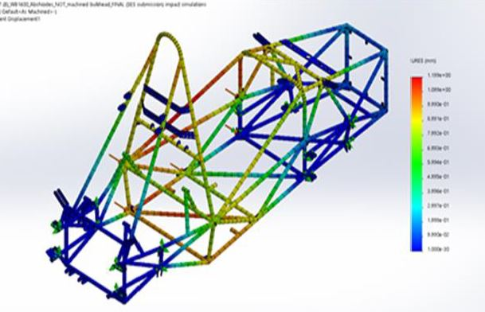
Figure 129: University of Charotar SIS Analysis

Benchmarking – Front, rear and main hoop concepts (Brandon Guzman)
While conducting research and benchmarking with other Universities formula teams State of the art (SOTA) designs, the team was able to narrow down our own design concepts to the one that best meets the present and other sub team deliverables. A few goals from the chassis specific sub team are regarding larger front hoops, more room in cockpit/pedal box, and proper triangulation. In addition, NAU’s previous FSAE team from the 2024 competition did not get the opportunity to include an aerodynamics aspect to their vehicle design, this year it is one of our sub teams goals to also create a design that could incorporate this feature to allow for more downforce and less drag on the vehicle. In this section of the report, a brief description of 3 SOTA chassis designs from other universities followed by the team’s final selected design that will later be used in section 4.4 as the datum for the Pugh chart regarding concept selection.
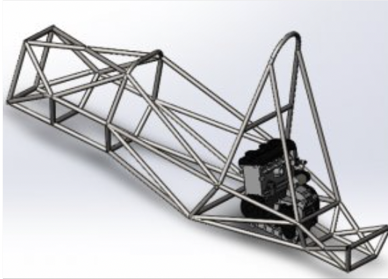
Figure 13: San Diego state Chassis
In Figure 13 above, this is the chassis design from San Diego state during the 2010 FSAE competition. Although an older design it still performed admirably enough to be show cased at SolidWorks world. This is due to its robust design from being properly triangulated, the large front hoop with extra pedal box room, and cockpit space Which is why this design was selected for one of SOTA designs to benchmark the teams designs with.

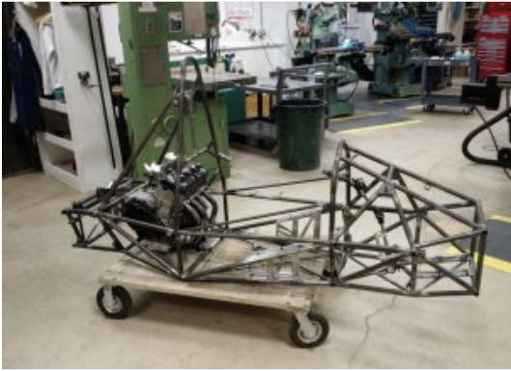
Figure 14: University of Delaware chassis design
This figure above showcases the university of Delawares chassis design from the 2017 FSAE competition. Their design includes a very large cockpit and front hoop, giving the driver lots of space. It is more of a stalky design but because they were a top performing school it is interesting to compare a variety of designs to see what does well and what doesn’t which is why this design was selected as a SOTA design.
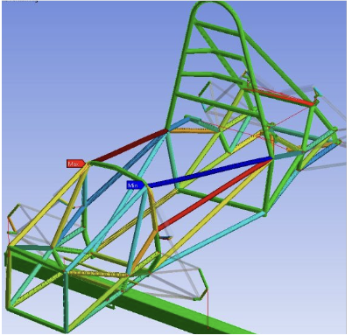
Figure 15: Purdue University chassis design
In figure 15 above, this was Purdue university’s chassis design from the 2020 FSAE competition. This chassis design scored 2nd place in the knowledge event competition of the entire event, and was the best design score a team has scored in the University’s history of competing in this competition. It is important to note this design also has a large front hoop and lots of space in the cockpit. For those reasons, this design was selected as the last SOTA design to be benchmarked with the team’s designs.

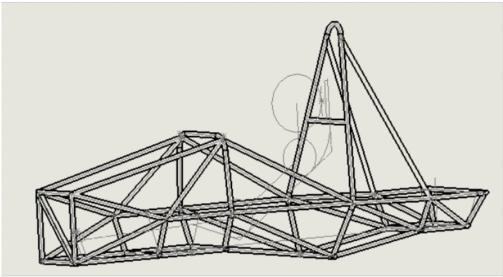
Figure 16: Final design for FSAE 2025 Car

Lastly, Figure 16 is a picture of the final selected CAD design for the 2025 car. In this final design, the team increased the height of the front hoop, made the rear suspension box smaller, and increased the width of the cockpit. The front hoop size was one of the most notable changes for the design, this was done for safely in case of the event of a roll over and to implement more aerodynamic designs to the car. It is also important to note that the other designs chosen as the teams SOTA designs also incorporate a large front hoop. More description as to why this design was selected will be further described in section 4.3, section 4.3 and section 4.4 further down in this design report.

Literature Review (Everyone)

Alexandra Brister – Seat Belt/ Seat/ Mounting System
THe following resources provide a foundation for benchmarking, analyzing, and designing the systems within the cockpit. These collectively address force dynamics, safety standards, and crash simulations.
[1a] Bruno Muss. "Crash test numerical analysis of a Formula SAE vehicle," YouTube, 1/17/2018. https://www.youtube.com/watch?v=c8k9Idy5kwk
This video shows an impact simulation of a Formula SAE vehicle using LS-Dyna software. It shows a visual and computational insight into the safety systems and how they behave during a crash. It relates to the project because it allows for the team to observe how the seat belt systems behave under a simulated crash; this offers data for comparison with theoretical models which helps validates the design choices for the seat belt stress analysis.
[2a] C. D. Carter, C. B. Sherman, and R. D. Matthews, “Design of a Formula SAE race car: Vehicle Dynamics and Performance,” SAE Technical Paper Series, Feb. 1982. doi:10.4271/821092 Aerodynamics
This discusses the dynamics of the vehicle and the aspects of performance for a Formula SAE standard. This discusses how the forces are transmitted through the vehicle; it is important to understand how the seat belt system reacts during impacts or maneuvers of the vehicle. This paper shows how to apply Newton’s laws in real world examples, it provides case studies show how to optimize the performance of seat belt systems with different conditions.
[3a] C. Itu, A. Toderita, L.-V. Melnic, and S. Vlase, “Effects of seat belts and shock absorbers on the safety of racing car drivers,” Mathematics, vol. 10, no. 19, p. 3593, Oct. 2022. doi:10.3390/math10193593
This paper explains how the driver's safety is impacted by the seat belt systems in various scenarios. This is useful for the mathematical modeling for calculating the stress of the seat belt system under impact conditions and use this information to assess the safety and design for the application.
[4a] The, Dynamics: Force and Newton’s Laws of Motion. 2019 (Chapter 4).
This chapter covers Newton’s Second Law of Motion, it focuses on the relationship between acceleration, force, and mass. Using the Newton laws to analyze the forces acting on the seat belt systems during impact. This creates a foundation for calculating the crash forces to understand the dynamics that act on the driver during an impact.
[5a] K. Baszczyński and M. Jachowicz, “The Effect of the Use of Full Body Harnesses on Their Protective Properties,” International Journal of Occupational Safety and Ergonomics, vol. 15, no. 4, pp. 435–446, Jan. 2009, doi: https://doi.org/10.1080/10803548.2009.11076823.
This provides insight into understanding the long-term effectiveness of racing harness systems, it expresses the importance of periodic maintenance for the protective features. It aids in considering the durability and the shelf life of the seat belt product, this ensures that it remains effective over time, specifically in racing environments.
[6a] R. G. Budynas, J. K. Nisbett, and J. E. Shigley, Shigley’s mechanical engineering design. New York, NY: McGraw-Hill Education, 2020. Chapter 3
This provides information for a foundation on the behaviors of materials under stress and how the forces are distributed across the system. It discusses the force distribution in a 6-point harness system, this explains how the lap, submarine, and shoulder belts share the forces from impact. This forms a basis for understanding stress analysis on the seat belt systems. This ensures uniform force distribution across the system to increase safety.
[7a] “SAE standards for Mobility Knowledge and Solutions,” SAE International, https://www.sae.org/standards?utm_source=google&utm_medium=ppc&utm_campaign=LVL_SAE_SCH_GSE_NTN_GPM_B2C_Standards&utm_content=Standards&utm_term=B2C&utm_device=c&utm_keymatch=p&utm_adposition=&gad_source=1&gclid=CjwKCAjw0aS3BhA3EiwAKaD2ZSgsuuN9rfyeBQE_uWePei2JlxfRiqc2r97IeRPudAJ_66PtXDuT6xoC7T4QAvD_BwE (accessed Sep. 17, 2024).
This website outlines the standards for vehicle safety and efficiency. This provides essential information on the safety requirements specific to the seat belt harness. This further benchmarks for safety for the system.
[8a] B. Herbstreit, “Seat & Firewall Design for Cornell Racing FSAE,” Dec. 2017. Available: https://www.ergofoundation.org/images/Bailey_Herbstreit_%20Seat_and_Firewall.pdf
This document discusses the design for the seat systems which has insigight into the integration of seat belts, this provides optimal driver protection
[9a] H. Bergstrand, “F-SAE Race Car Seat Design -A user-centred concept development project.” Accessed: Nov. 27, 2024. [Online]. Available: https://hampusbergstrand.com/wp-content/uploads/2017/02/F-SAE_race_car_seat_design_Hampus_Bergstrand_2015_Newcastle.pdf
This document focuses on the seat design being ergonomic and have optimal safety features which would enhance the seat belt system integration.
[10a] M. Scheitlin and T. Bräunl, “Renewable Energy Vehicle Project: Pedal Box Design for Formula SAE,” 2011. Available: https://robotics.ee.uwa.edu.au/theses/2011-REV-3-PedalBox-Scheitlin.pdf
This details the pedal box design, which is relevant to the mounting system in the cockpit .

Ryan Meger – Torsional Stiffness
For my portion of the literature review, I researched how the chassis will react to torsional forces when cornering. I first looked at a well-known vehicle dynamics textbook, Race Car Vehicle Dynamics Milliken Milliken [1r]. This familiarized me with chassis stiffness, impact on handling and the dynamics associated, optimization, and driver feedback. Next, I needed to know the required equations and calculations to find the torsional rigidity, which was found using a combination of Analysis of Torsional Stiffness of the Frame of a Formula Student Vehicle [2r] and Formula SAE Chassis System [3r]. Both sources helped me develop method to analyze a chassis for its torsional rigidity. To test torsional rigidity, SolidWorks’ simulation tool was chosen for its available resources and ability to test different designs efficiently. I learned how to use the simulation tool by watching SolidWorks Simulation By Mahtabalam [4r] and SolidWorks FSAE & Formula Student Tutorials [5r]. The simulation tool is only as good as how you know how to use it. Studying on how to use the simulation tool was paramount to having correct results. Sources: ANALYSIS OF FSAE CHASSIS [6r], MEEG 402-010 Chassis Design Report [7r], and Modeling of a chassis for an SAE formula car [8r] for a larger selection of frame types to compare to each other for our team’s chassis design. To further my knowledge and understanding of a Failure Mode and Effect Analysis (FMEA) I read Understanding FMEA Calculations[9]. It goes over all the calculations regarding a FMEA analysis and their importance. It explains what the RPN value is and their results. Next I wanted to apply it to our SAE Formula capstone. Watching a video called DFMEA explained[10] it goes over the important functions and subfunctions of a SAE Formula car and important failure points to address in the analysis.

Gustavo Ruiz – Chassis Frame Design
[1g] "Design and Analysis of FSAE Chassis for Safe Conditions" (Paper)​
Helpful design parameters and calculations to run our design through, as well as finding vertical center of gravity methods.​

[2g] "FEA Analysis of FSAE Chassis" (Paper)​
Main goal highlighted were to decrease weight and increase torsional rigidity, helpful ANSYS simulation of stresses and torsion.​

[3g] "The Science of Vehicle Dynamics", Chapter 3 "Vehicle Model for Handling" (Book)​
Great explanation on aerodynamics in a Formula car, and goes more in depth on front and rear vertical forces​

[4g] "Fundamentals of Aerodynamics", Chapter 19 "Turbulent Boundary Layers" (Book)​
Helpful way to create turbulent modeling and find characteristics of a turbulent flow.​

[5g] "Renewable Energy Vehicle Project: Pedal Box Design for Formula SAE" (Paper)​
Future Work ideas from pedal box are to decrease weight and use an angle-mounted cylinder to decrease pedal box length, like our goal. ​

[6g] "Formula SAE Rules 2025", F- Chassis and Structural (Standard)​

[7g] M. L. Mohamad et al., “Design and static structural analysis of a race car chassis for Formula Society of Automotive Engineers (FSAE) event,” Journal of Physics: Conference Series, vol. 908, p. 012042, Oct. 2017. doi:10.1088/1742-6596/908/1/012042

Main design constraints and regulations that are frame needs to abide by. Helpful templates to ensure ergonomics of vehicle and as well as its functionality.

Brandon Guzman Benchmarking and Bending(b)
[1b] M. Planchard, “San Diego state university formula SAE team showcased at Solidworks World,” SOLIDWORKS Education Blog, https://blogs.solidworks.com/teacher/2014/01/san-diego-state-university-formula-sae-team-showcased-at-solidworks-world.html
Source 1b is a blog from SolidWorks showcasing the sand Diego state chassis that was very helpful for benchmarking designs for the chassis. This aided in the selection process of our own designs.

[2b] C. Dodd, N. Geneva, P. Geneva, and C. Morris, Dr. Steven Timmins , rep., 2017 ​
Source 2b is the final report from the university of Delaware on their chassis design for the 2017 competition. This source was full of a lot of insight on designing and modeling the chassis as well as bending and welding it together.

[3b] “Purdue Formula SAE scores 2nd place; Best Design Score in their history,” Mechanical Engineering - Purdue University, https://engineering.purdue.edu/ME/News/2021/purdue-formula-sae-scores-2nd-place-best-presentation-score-in-their-history-
This source is from Purdue university showcasing their best design score in their history at the competition, this document was full of helpful insight and was also a main source for benchmarking.

[4b] William F Milliken and Douglas L Milliken. Race car vehicle dynamics. Vol. 400. Society of Automotive Engineers Warrendale, 1995​
Source 4b is a book the whole team is utilizing for the design process of the chassis, this book is full of useful equations regarding analysis of acceleration weight transfer, stiffness, and force impact.
[5b] Martin Meywerk. Vehicle Dynamics. John Wiley & Sons, 2015​
This is another useful book full equations for weight transfer and forces on the vehicle.
[6b] “The construction Process: Pipe and Tube bending,” https://www.herl.pitt.edu/indiachair/indiachairsh/cl_bend.html#:~:text=Rule%20for%2090%20degree%20and%20180%20degree%20Bends&text=180%20degree%20bends%3A%20Multiply%20the,length%20of%20the%20curved%20section.
Source 6b is a website that is dedicated to tube bending, this will be utilized during the beginning manufacturing processes of the car to ensure tube will not need to be remade.
[7b] “Mastering small tube bends,” YouTube, https://youtu.be/MymUqxuCKv4?si=pWnrkCMSN0BtZO4K
Source 7b is a YouTube video that goes over pipe bending basics, this is another source that will be useful for the manufacturing process of the final chassis design.
[8b] “TFS: Tube Bending Basics 1 - What You Need to Know,” YouTube, https://youtu.be/3n_lf2RHIPs?si=NaGZuH7i3eOT0MqW
This last source is another YouTube video that goes over roll cage designs, as well as how to effectively bend using centerline radius of tubes. This will also be useful during the manufacturing process of the cars design.

[9b] ennologic, Ed., “Emissivity table for infrared thermometer readings,” Emissivity Table for Infrared Thermometer Readings, https://ennologic.com/wp-content/uploads/2018/07/Ultimate-Emissivity-Table.pdf (accessed Nov. 21, 2024).

Source 9b is an emissivity table that was utilized during the theoretical analysis of the firewall, this table contained emissivity values for standard and reflective materials. This will also be useful during the final mathematical analysis of the firewall.

[10b] F. Wang, L. Cheng, Q. Zhang, and L. Zhang, “Effects of heat treatment and coatings on the infrared emissivity properties of carbon fibers: Journal of Materials Research,” Cambridge Core, https://www.cambridge.org/core/journals/journal-of-materials-research/article/abs/effects-of-heat-treatment-and-coatings-on-the-infrared-emissivity-properties-of-carbon-fibers/B82F9713F9E2FD2417F7E1AA7EAFEFB3 (accessed Nov. 20, 2024).

This source was used specifically for finding the heat transfer rate between the exhaust and seat, the teams plan is to have the seat constructed of coated carbon fiber. This source has values of the emissivity of coated carbon fiber and aided in the mathematical analysis.

[11b] T. L. Bergan and A. S. Lavine, “13.3.4, Two-Surface Enclosures in Series and Radiation Shields,” in Fundamentals of Heat and Mass transfer, 8th ed, John Wiley and sons, 2019, pp. 808–811
This section of the heat transfer book aided in constructing the Thermal resistive network for the firewall. The equations used involved the heat transfer rate between two surfaces and a radiation shield between them which is what the reflective aluminum firewall will act as.
[12b] [1] S. International, “Formula SAE Rules 2025,” 2025 formula SAE rules V.1 , https://www.fsaeonline.com/cdsweb/app/NewsItem.aspx?NewsItemID=379e4a8a-80a2-4a74-87c2-6f2de4212270 (accessed Nov. 21, 2024).
This final source is the rulebook for the FSAE competition and gives parameters on how the firewall should be constructed as well as what temperature the components the diver touches should not exceed. This will be utilized for mathematical analysis for the final design of the firewall.

3.2.5 Carson Kent Aerodynamic Design
[1c] "Aerodynamics Analysis of a Formula SAE car" (Paper)
Helped in giving an overview of all components studied when designing aerodynamics

[2c] "Aerodynamics of Road Vehicles, 5th edition" (Book)
Gives tons of information about production passenger cars and other various road vehicles

[3c] "Aerodynamic Study of Formula SAE car" (Paper)
Gives great insight into design of previous SAE cars and good practices

[4c] "NACA 4-digit airfoil generator" (standard)
Helped me pick out which airfoil geometry will be best for this application.

[5c] "Introduction to Aircraft Airfoil Aerodynamics" (paper)
It gave me a broader understanding of airfoils outside of car aerodynamics.

[6c] "How an Airfoil Works – MIT" (website)
Showed some great methods for characterizing an airfoil for different applications.

[7c] "Theory of Airfoil Lift Aerodynamics" (book chapter)
Helped give an overall grasp of how airfoils are generally used

Mathematical Modeling (Everyone)

Seatbelt Stress/ Safety for 6-point and Seat Mounts– Alexandra Brister
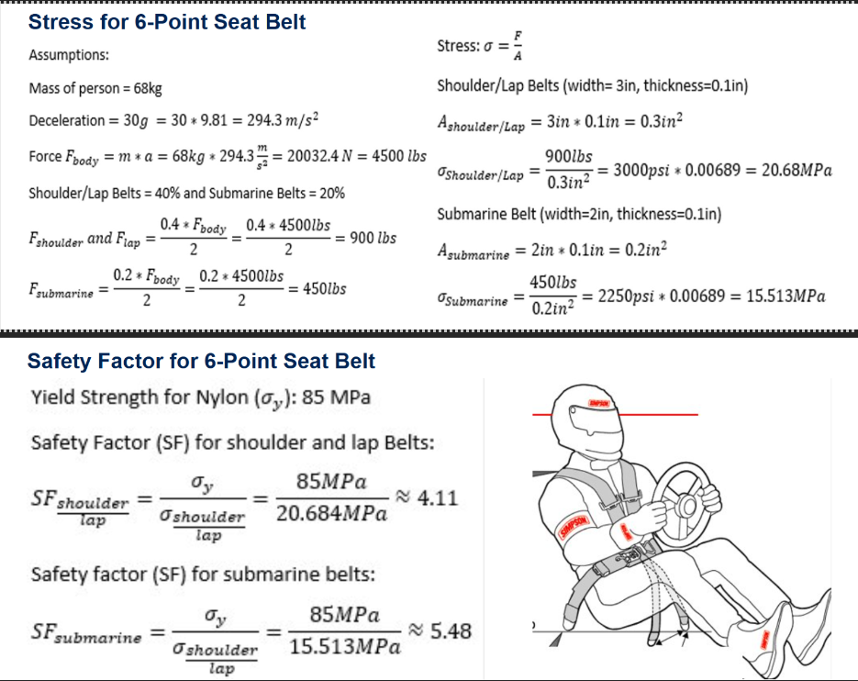
Figure 3.3.1.1: Stress and FOS for 6-Point Seat Belt
The mathematical modeling analyzes the stress and safety factor of a 6-point seat belt system. The analysis starts with basic assumptions, this includes a person's mass, deceleration of 30g, which shows 30 times that gravitational acceleration. The total force acting on the body is calculated based on the parameters which is about 20034N or about 4500lbs. This force is then distributed between the different straps of the seat belt system. The shoulder and the lap belts bear 40% of the total force and the submarine belts bear about 20% of the total force. Using these forces calculated for each belt, the stress can be determined by the force divided by the cross-sectional area of the belt. The cross-sectional areas of the shoulder and lap belts is 0.3in² the calculated stress is about 20.68MPa. For the submarine belts the cross-sectional area is 0.2 in² the stress is about 15.51 MPa. The factor of safety (SF) for the 6-point seat belt is determined using the yield strength of Nylon (85 MPa). The safety factor is calculated by dividing the yield strength of the belt by the stress of the belt. The safety factor (SF) for the shoulder/lap is about 4.11 which means that the material is over four times stronger than the stress applied to the belts. For the submarine belts the safety factor is about 5.48 which shows a great margin of safety. These calculations show that the 6-point belt system is within the safe limits, indicating that it will not fail under high impact forces.

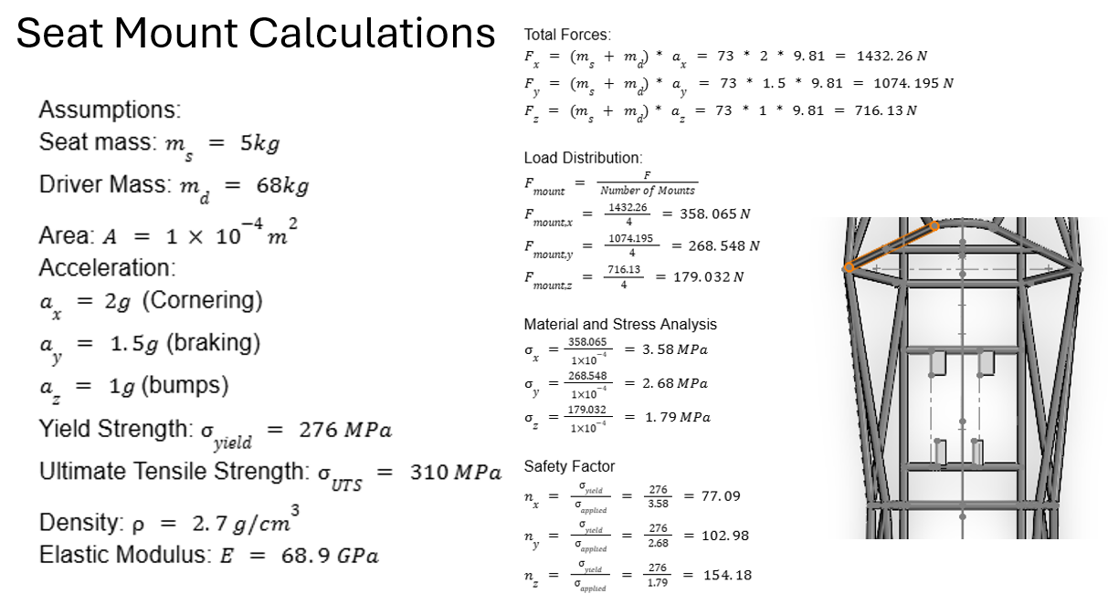
Figure 3.3.1.2: Stress and FOS for Seat Mounts
This analysis does the calculations for the seat mounts. There are several assumptions that were needed to determine the forces and safety factor, the resulting total forces of 1432.26N, 1074.195 N, and 716.13 N. These forces are evenly distributed among the four mounts, which gives each of the mount forces of 358.065N, 268.548 N, and 179.032 N. The resulting safety of factors are high which indicates that the mounts are over-engineered and robust.

Finite Element Analysis (FEA) of the Chassis – Ryan Meger

Torsional Analysis
Torsional stiffness of a race car is important for a race car because it improves handling, weight transfer, suspension optimization, and consistent aerodynamics performance. Making this analysis have meaningful impact on the performance of the car. An ideal stiffness the team has chosen is high, at 2400 Nm/deg. The equations below explain how I tested and calculated the theoretical torsional stiffness.
$C_{T}=\frac{T}{α}$ [1]
The variable T is the applied Torque in Nm. This value is calculated using equations [3] and [4]. Alpha is the angular deflection in degrees using equation [2], and $C_{T}$ is the torsional stiffness in Nm/deg.
Figure 18: Deformation Triangle
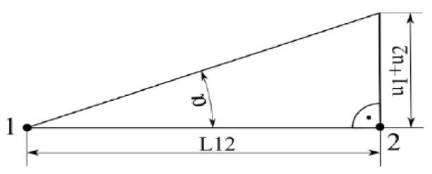
$α=\arctan\left(\frac{u_{1}+u_{2}}{L12}\right)$ [2]$⁡$
$F_{lateral}=m × a_{lateral}$ [3]
$T_{applied}= \frac{F_{lat}}{\# of points}$ [4]
The part of the frame that will be analyzed for displacement is the front hoop, where a most of the torsional forces will be acting upon when driving. The figure below gives a representation of how a real-life experiment would gather displacement data, instead it will be conducted in solid works using the displacement plot in SolidWorks simulation tool. The mass of the car was estimated to be 250kg and a lateral acceleration of 2 Gs. Displaced along 4 points on the front suspension box, giving an applied force of 1103N.
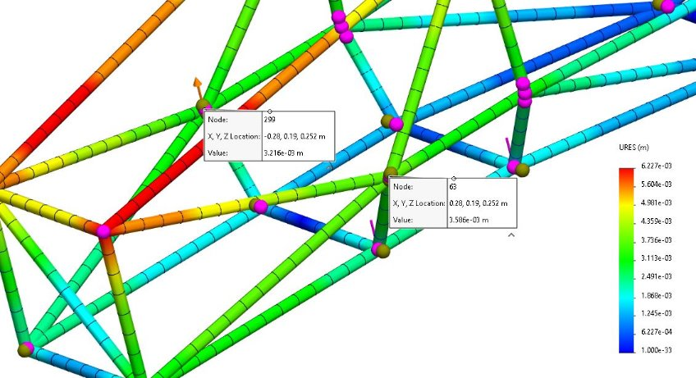
Using the max displacement on the front hoop, at 3.586x10-3 meters, a theoretical Torsional rigidity of 1932.7 Nm/deg. This does not meet our goal of 2400 Nm/deg but is high enough to be competitive.
Figure 19: Displacement Plot

Front and Side Impact Analysis
The forces in the next two analyses were calculated using the following equations:
$p=mass ×velocity$ [5]
$F= \frac{p}{time} [N]$ [6]
The mass is 250kg and velocity was estimated to be 70 mph. The impact time was set at 0.25 seconds. Resulting in a force of 31,300 N.

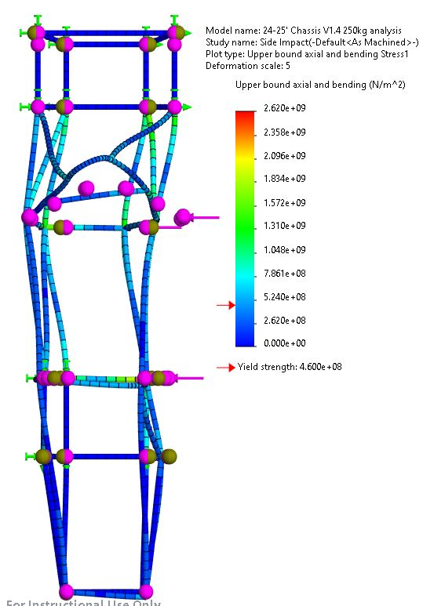
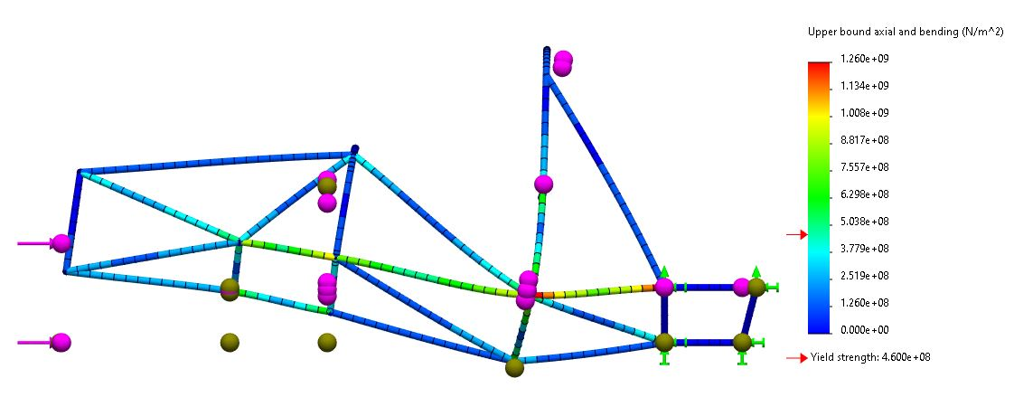
Figure 20: Top View of SIS Impact Stress Plot
Figure 21: Side View of Front Impact Stress Plot

Bending mathematical modeling – Brandon Guzman
This section of this report will cover the bending calculations and analysis for the beginning manufacturing process of the front and main hoops for the final designs. The calculations used are simple but will aid in ensuring the lengths of bending won’t be to short and too long. Accuracy here is important because of material cost and time, mistakes could cost money and take away time meant to be spent on other parts of this project. The figure below is the drawing of the front hoop, and the angles used for the calculations described further below.
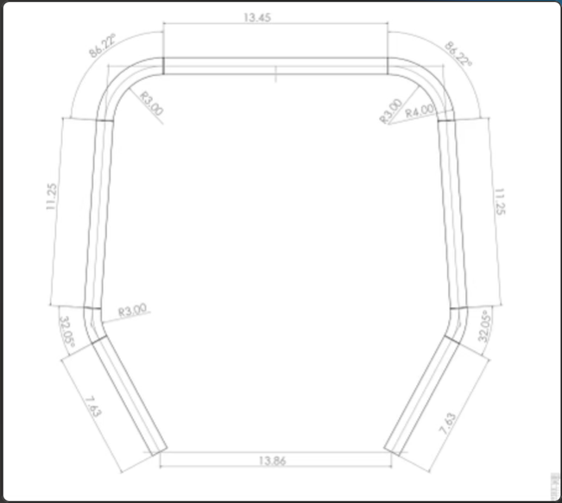
Figure 22: Drawing of front hoop
The calculations used were found from a website about tube bending [6b], which utilizes a bending constant that allows for users to find the total length of the tube using simple calculations. The constant is equal to 0.01745.
$Length=r ×angle × const$ [7]
Equation 7 will be utilized for both angled parts of the front hoop drawing. The first angle is 32.05 degrees which is a smaller section and using equation 7 the length was found to be around 1.7 inches but was rounded up to 2 inches to be safe during manufacturing. The length of the bigger angle which was around 85.76 degrees was found to be around 4.5 inches but was rounded up to 5 to be safe. The reason these angles were increased so much was to make sure even if the team uses too much tube, we can still cut off excess to be safe. After these calculations were done the total length of tube was calculated to be around 68 inches in total for the front hoop. The figures below show the manufacturing process for the front hoop and main hoop, which follows the same process described above.

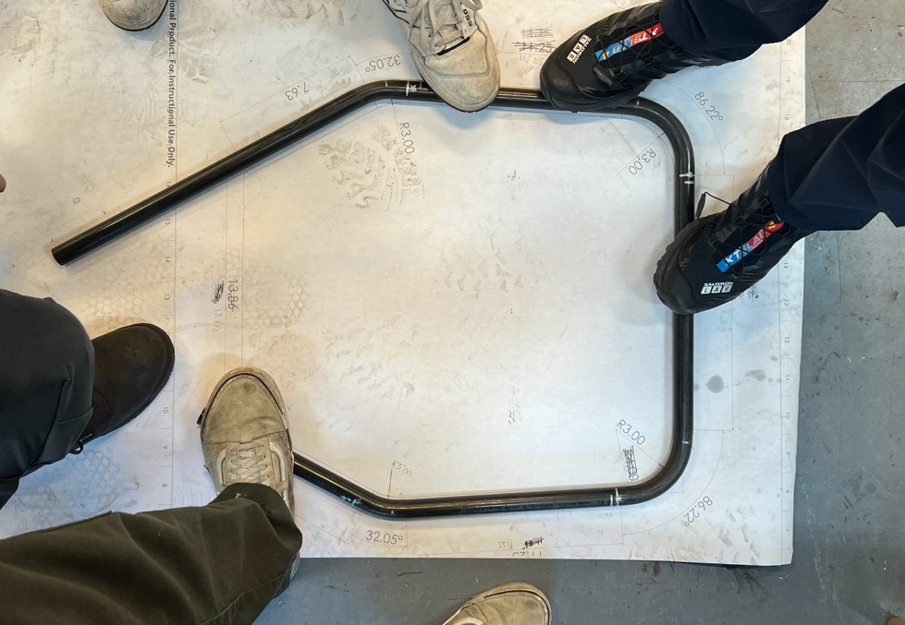
Figure 23: Front hoop over drawing
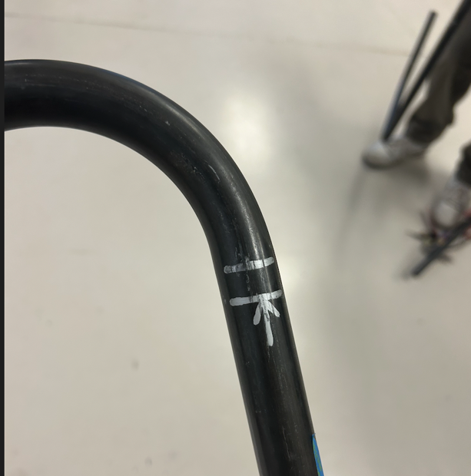
Figure 24: Offset of bending chuck
It is important to also note that every bending chuck has an offset from when the true bend starts, figure 24 demonstrates the offset by showing where the bend starts from the marks made. The offset is around a half an inch, so wherever there was a bend, the team measured half an inch from the marking and placed an arrow in front of it, the arrow represents how far the tube will be placed in the chuck. This was not added to the calculations but was used during the manufacturing process. The same process was followed for the main hoop, which is shown in figure 25 below.
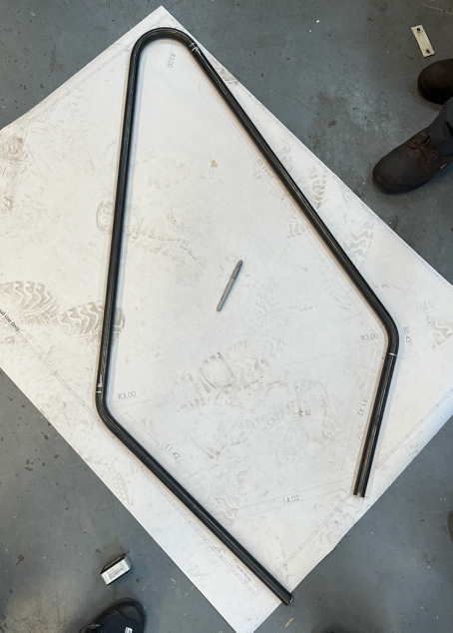
Figure 25: Main hoop over drawing

Preliminary Aerodynamics Mathematical Modeling – Carson Kent
Aerodynamic calculations were performed on the chosen airfoil geometry using the Vortex Panel Method, to find coefficient of lift and drag. Results prove there are high pressure zones at the front of the airfoil which produce the lift and drag when in fluid flow. Negative lift values show the amount of downforce and after tests at –30 degrees for angle of attach, there is a lift coefficient of around –3 which proves these airfoils will be capable of producing significant downforce.

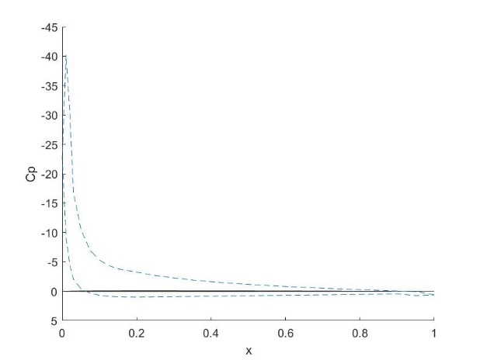
Figure 26: Pressure plot for –30 degrees angle of attack
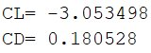
Figure 27: Lift and drag for –30 degrees angle of attack

Design Concepts

Functional Decomposition (Ryan Meger)
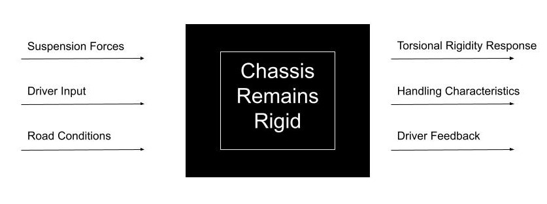
The main concept that the chassis must accomplish while driving, is to be stiff under any loads it receives. Inputs on the chassis are from the suspension, driver, and road. All of which test the chassis’ ability to resist torsional forces.
Figure 28: Chassis Black Box Model

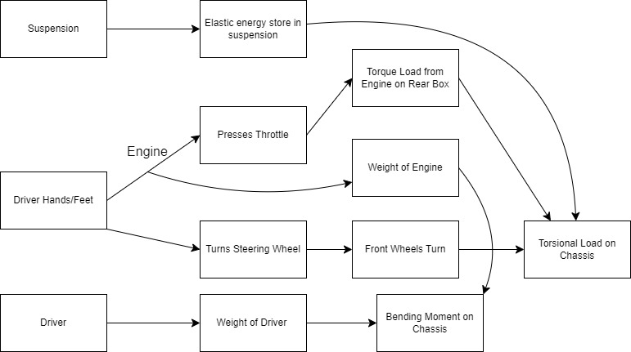
Next is the functional model for the chassis. It’s end goal is the same as the black box, which is that chassis remains rigid. This model dives deeper into the interactions with the chassis and the associated outputs and system behavior.
Figure 29: Functional Decomposition for Chassis

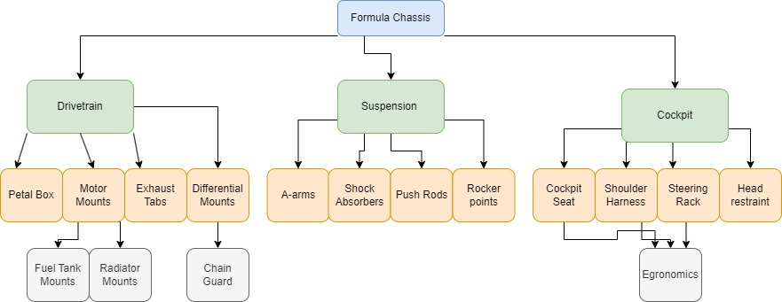
The physical decomposition consists of all the components that are connected to the chassis. All need to be considered in order for the sub-teams to successfully integrate their designs onto the chassis. Keeping track of all the components helps with organization and not forgetting what is needed.
Figure 30: Physical Decomposition of Chassis

Process Diagram (Gustavo Ruiz)
The process of finalizing the seat design is critical to the success of the FSAE chassis and its related subsystems. The seat design establishes the location of the driver’s seat by finalizing the seat mounts and brackets, locking in its position within the chassis. This step provides a foundation for subsequent design elements, such as the exhaust and fuel tank. Once the seat position is finalized, the head restraint, which extends rearward of the main hoop, can be designed. The head restraint is essential for driver safety during impacts and serves as a spatial reference for the next step in the process.
With the seat and head restraint positions determined, the firewall can then be designed to fit snugly behind these components. The firewall serves to shield the cockpit from engine heat, enhancing driver safety while maximizing the available space in the engine box. This positioning ensures that the firewall aligns closely with the seat and head restraint, allowing for optimal use of chassis interior space. Finally, once the firewall’s design is finalized, the drivetrain team can proceed with designing, or at least adjusting the size, of the fuel tank and exhaust system based on the available space.
This process diagram is important because it ensures that each subsystem is addressed in a logical order, minimizing rework and ensuring compatibility. The process diagram will help the team stay on track with the project and meet necessary safety and performance requirements. As seen below in Figure 31, the process diagram shows the flow of these steps. The chassis team aims to complete this design process before the end of the semester.

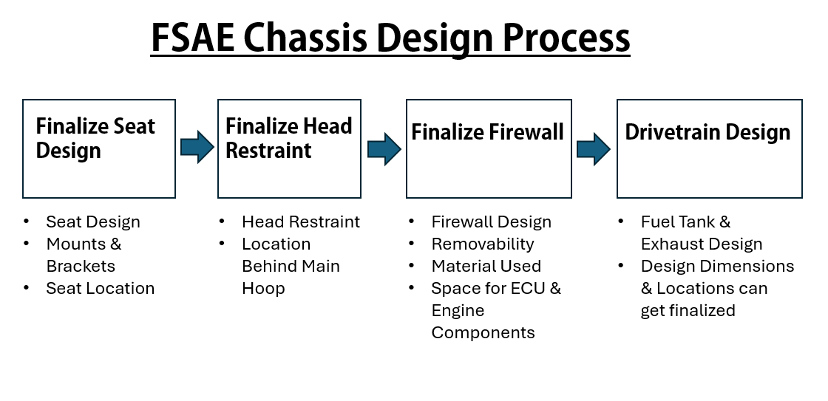
Figure 31: Design Process Diagram

Concept Generation (Everyone)

Chassis Generation Ryan Meger & Gustavo Ruiz
Table 1: Frame Design Concept Generation
Criterion | Design 1 (Final)  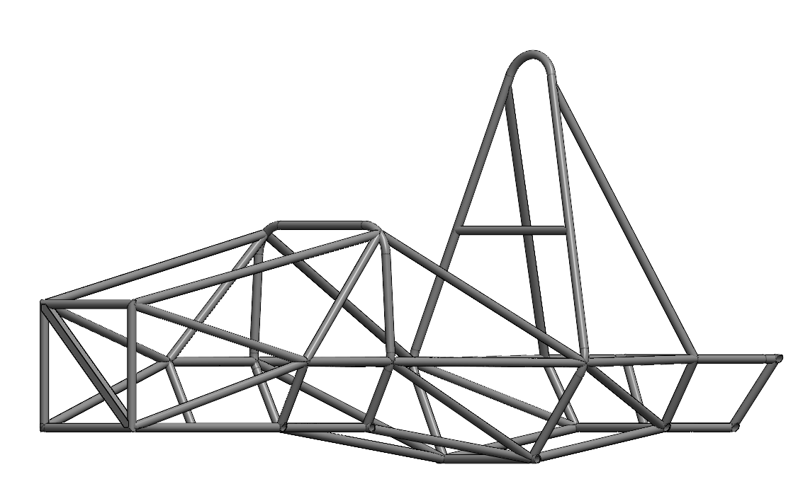 | Design 2  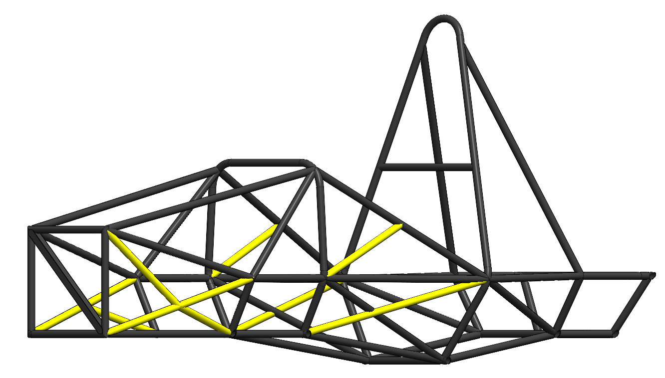 | Design 3  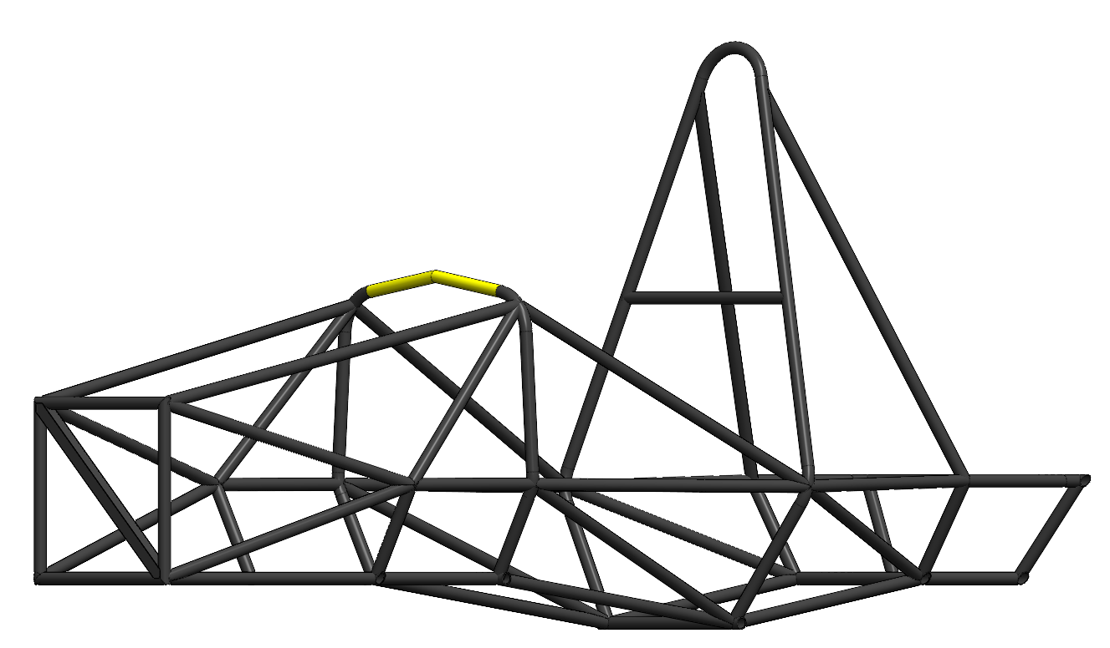 | Design 4  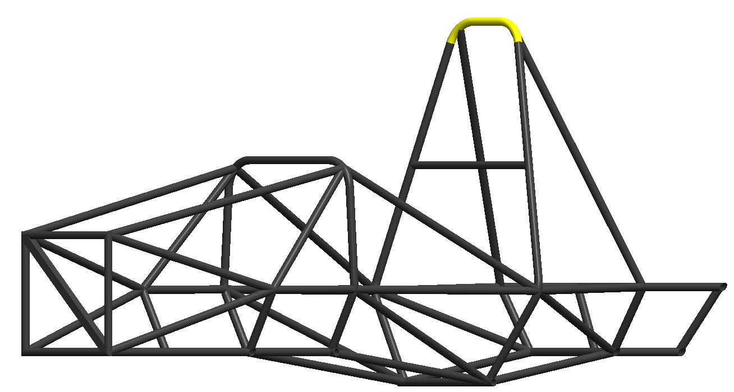
Torsional Rigidity | 4 | 5 | 4 | 4
Cost | 4 | 2 | 4 | 4
Weight (lbs.) | 4 | 1 | 3 | 4
Manufacturability | 4 | 2 | 3 | 3
Safety | 4 | 5 | 4 | 4
Total | 20 | 15 | 18 | 19

The concept generation for the chassis was kept simplistic to encourage specialized designs for the specific sections of the chassis design. The first design is our final design, having the third best torsional rigidity, which can be referenced in Table 4. It also is the second lightest, meaning it is cheaper and will perform better than the heavier frames. Design 2 wanted to incorporate more triangulation to increase torsional rigidity. It did by 15%, but at the cost of increases the weight by almost 12%. The weight increase did not justify the increased stiffness of the chassis, since our designs is stiff enough to be competitive. Design 3 aimed to change the design of the front hoop, allowing for more cockpit gauges and leg room to be possible. It did however make the front hoop more complex to manufacture and increased it weight. The last design aimed to making the main hoop less dramatic in its top bend. This would allow for better integration with attachments for aerodynamics. The bend would consist of two smaller bends, to make a flatter top surface to attach the aerodynamics to. Its design is great but would make manufacturing difficult and might not even be used if we don’t implement large rear wing.

Seat Belt Systems – Alexandra Brister
Table 2. Seat-Belt Systems Concept Generation
Criterion  Scale 1 to 5 | Design 1: 5-point  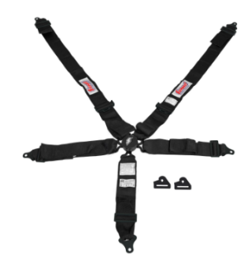 | Design 2: 6-point  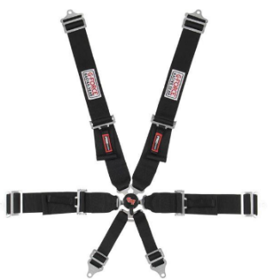 | Design 3: 7-point  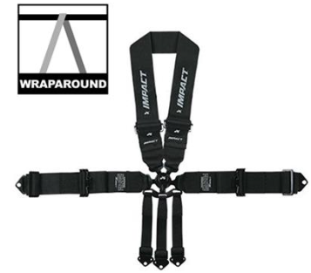
Cost:  1 being the most expensive  5 being affordable | 5  This is the most expensive option | 4  This option is expensive however it is more affordable than Design 1 | 1  This is the cheapest option however it would not be able to endure the stresses
Force Distribution:  1 very poor force distribution, with significant pressure on small areas  5 Force distribution across the body, minimizing the pressure points | 3  This option is a 5 point seat belt system and would have poor force distribution on all belts. This would add pressures on the driver | 4  This option would enough for the stresses and forces it will endure. It will evenly distributing the stress and forces | 5  This design would over-engineered design and unnecessary for the forces and stresses hat it would endure.
Comfort:  1 Uncomfortable, causes pain and discomfort  5 Very Comfortable, can wear belt for long periods | 2  With the 5-point seat belt it puts pressure or could cause pain for the driver in some areas | 4  This would be the most comfortable because the forces are evenly disturbed on all the belts | 3  This system would be uncomfortable because of the amount of belts can cause discomfit and interfere with the driver
Durability:  1 very low durability, wears out quickly  5 the system is built to withstand wear and tear | 4 | 5 | 5
Safety:  1 Poor protection, high risk during impacts  5 Excellent protection, low risk during impacts | 3 | 5 | 5
Total: | 17 | 22 | 19

Based on the concept generation table, the 6-point seat belt system is the best choice, it offers balance of comfort, cost, and safety. While the 7-point seat belt systems would provide better protection, the cost is extremely high and due to the complexity, it ranks lower than the 6-point system.
Table 3: Nose Cone Designs
Criterion  Scale 1-5 | Design 1:  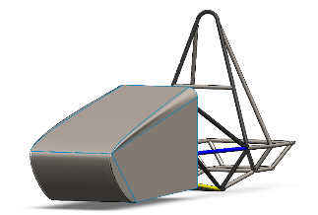 | Design 2:  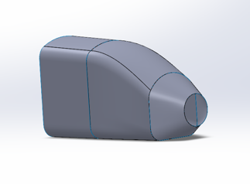 | Design 3:  
Driver Visibility | 4 | 5 | 3
Performance | 4 | 4 | 3
Removability | 5 | 3 | 5
Applicability | 4 | 3 | 4
Total: | 17 | 15 | 15

Design 1 is the best design thus far however there have not been any full simulations done on these designs. Ansys Fluent will be used in the near future to better rank these designs and choose the best one to move forward with.

Selection Criteria

Chassis Selection Criteria – Gustavo Ruiz
The selection of the final chassis frame design was based on five primary engineering criteria: torsional rigidity, cost, weight, manufacturability, and safety. Each criterion is rooted in the engineering requirements of the chassis and can be quantified through calculations and well-established specifications.
Torsional rigidity is a critical parameter for the chassis frame as it directly affects the vehicle’s handling and overall structural stability under dynamic loading conditions. The torsional rigidity of each frame design was found by using SolidWorks Simulation for stress and torsional rigidity. A summary of the torsional stiffness values for the evaluated designs is presented in Table 4.

Table 4: Design Torsional Rigidity
Design Option | Torsional Stiffness (Nm/°)
Design 1 | 2009.25
Design 2 | 2321.7
Design 3 | 2091.05
Design 4 | 1948.27

The cost analysis focused solely on the material cost. For the materials, we obtained quotes from Industrial Metal Supply and Online Metals for the steel tubing used in the designs. The manufacturing cost was estimated based on the complexity of the frame constructing, including the number of welds, joints, structural members with respective cuts, and specialized process required such as tube bending. Based on the frame design concept generation showed earlier in table 1 our final design which is design 1, design 3, and design 4 have a really similar amount if each sized tube; 17 feet of Size A tube at $8.85 per foot totaling to $150.45, 37 feet of Size B tube at $9.80 per foot totaling to $363.00, and 46 feet of Size C tube at $10.11 per foot totaling to $465.06. Our design 2 received the lowest score for cost due to more structural members, where it has 8 feet more of size B tubing and 5 feet more of size C tubing, totaling to a total of around $125.00 more, and we also need to consider purchasing for safety stock in case of any mistakes or variability in usage.
The weight of the chassis is a key factor in the overall performance of the vehicle, particularly in terms of acceleration, braking, and fuel efficiency. The total mass of each chassis design was found from SolidWorks “Mass Properties” tool, after setting the frame material to AISI 4130 steel annealed at 865°C. The lighter the frame, the better the vehicle performance would be, as long as the design still met safety requirements. Table 5 below shows the weight for each design.

Table 5: Design Total Weight
Design Option | Weight (lbs.)
Design 1 | 62.72
Design 2 | 69.97
Design 3 | 63.01
Design 4 | 62.67

Manufacturability was evaluated based on the complexity of the design and the ease with which it could be fabricated using available tools and processes. This including assessing the number of welds, the complexity and amount of tube notching and tube bends. Designs that required more complex jig setups and specialized tube bending were deemed less favorable. Design 2 had more structural support members so that meant more difficult to reach welds, and more tube notching so it received the lowest score. Designs 3 and 4 had one to two more bends so the bending of the those would require more time in the machine shop compared to design 1, which only had seven total bends.
Safety is a paramount and was evaluated based on the ability of each design to protect the driver in the event of the crash, our reengineering requirements are all from the FSAE rulebook. This includes compliance with FSAE safety rules and regulations, as well as the frame’s overall structural integrity. Stress analysis simulations were performed to assess the energy absorption capabilities and determine the likelihood of failure under front and side impact conditions.

Concept Selection

Concept Selection for Chassis Design (Ryan Meger)

Table 6: Concept Selection for Chassis Design
 | Weight (1-5) | Design 1(datum) | Design 2 | Design 3 | Design 4
Torsional Rigidity | 4 | + | ++ | 0 | 0
Cost | 3 | + | - | + | 0
Weight | 4 | + | - | 0 | 0
Manufacturability | 4 | 0 | - | - | 0
Safety | 5 | 0 | + | - | +
Total |  | +3 | 0 | -1 | +1

SCHEDULE & BUDGET (Gustavo)

Schedule
As of November 26, 2024, our chassis team has completed all tube notching for the frame, with the main hoop and front bulkhead fully welded. The jig is now in the machine shop undergoing its final fitment adjustments before tacking the frame together. The frame will be tacked starting from the rear and progressing to the front due to complications in the front section caused by the bent front hoop, particularly at the first node with a complex triangulation point. The jig assembly took longer than anticipated because of incorrect MDF cutout drawings and delays in manufacturing brackets. Tube preparation was also time-intensive, as most tubes required 1:1 scale cutout templates for precise tube notching. Additional delays arose from scaling issues with plotter drawings and the need to grind off areas the tube notcher could not reach. As seen in Figure 32, we are optimistic that the frame will be fully tacked by the end of the semester, and the SES will be ready for submission after adding a few remaining photos.

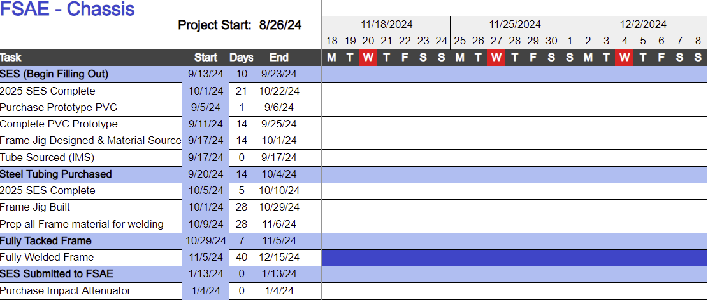
Figure 32: Chassis Ghantt Chart
Moving forward, we will shift our focus toward finalizing the tacking of the frame and beginning work on cockpit design components, including the firewall, seat, and head restraint. Meanwhile, the majority of the team will transition to prototyping aerodynamic components, starting with the nose cone. This strategic reallocation of resources ensures steady progress across all critical areas as we prepare for the next phase of the project.

Budget
The total budget allocated for the frame-body-aero sub-eam is $6,058.24, as outlined in Table 7. The primary expenses are focused on three key areas: frame materials, safety and cockpit components, and aerodynamic components. Frame materials, including various tubing sizes and the front bulkhead sheet, account for $1,333.48. Safety and cockpit components, such as the impact attenuator, harness, head restraint, seat, and firewall, total $1,470.00. Aerodynamic components, including body panels, aero parts, and the front nose cone, represent the largest single expenditure at $2,800.00.
Table 7: Chassis Budget
Chassis Budget
Category | Units | $/Unit | Total
Frame
Size A Tubing | 18.02 | $28.75 | $518.08
Size B Tubing | 36.1 | $7.10 | $256.31
Size C Tubing | 40.4 | $11.33 | $457.73
Size D Square Tubing | 1 | $45.60 | $45.60
Front Bulkhead Sheet | 1 | $56.36 | $56.36
Prototype
PVC 1in Pipe | 10 | $8.48 | $84.80
Duct Tape | 2 | $8.98 | $17.96
Jigging
Material |  | $336.40 | $336.40
Welding
Tig Rods ER70S-D2 | 1 | $50.00 | $50.00
Argon | 1 | $65.00 | $65.00
Safety Equipment
Impact Attenuator | 1 | $210.00 | $210.00
Harness | 1 | $260.00 | $260.00
Tabs & Fasteners | 1 | $200.00 | $200.00
Head Restraint | 1 | $100.00 | $100.00
Seat | 1 | $350.00 | $350.00
Floor Closeout | 1 | $100.00 | $100.00
Firewall | 1 | $150.00 | $150.00
Aero
Body Panels | 1 | $300.00 | $300.00
Aero Parts | 1 | $2,000.00 | $2,000.00
Front Nose Cone | 1 | $500.00 | $500.00
 |  | Total | $6,058.24
As detailed in Table 8, the total available budget is $6,058.24, with $2,095.52 spent so far on tubing, jigging, and initial prototyping. This leaves a remaining balance of $3,962.72, which ensures sufficient funds to complete the tacking and welding of the frame, cockpit component installation, and aerodynamic prototyping. With anticipated expenses for the rest of the semester totaling $484.76, the team remains financially on track and committed to completing all tasks within the allocated budget.
Table 8: Current Expenses
Current Expenses
Total Available | $6,058.24
Anticipated Expenses | $484.76
Actual Expenses to Date | $2,095.52
Resulting Balance | $3,962.72

Bill of Materials for JIG (BOM)
The jig, essential for assembling and aligning the chassis frame, was constructed using various materials, as outlined in Table 9. The total cost for the jig amounts to $367.25, covering all necessary components to ensure precision and stability during the frame construction process.
The primary material used was MDF board (3/4"x 4'x 8'), with three sheets purchased at a total cost of $160.41. These boards served as the base structure for the jig. Additional components included angle iron (1/8"x 2"x 48") for reinforcement, costing $35.45, and fasteners such as bolts, washers, and nuts to securely assemble the jig, totaling $156.79. A pack of screws was also used to fasten the MDF boards, costing $14.60.
This carefully selected combination of materials ensured the jig was robust and functional, allowing for precise alignment of the chassis members during tacking and welding. Despite some delays during its fabrication, the jig is now fully assembled and undergoing final fitment adjustments, ready for the next stage of frame construction.
Table 9: JIG BOM
JIG BOM
Part | Units | $/Unit | Total
MDF Board (3/4"x 4'x 8') | 3 | $48.98 | $160.41
Angle Iron (1/8" x 2" x 48") | 1 | $32.47 | $35.45
Washers (3/16" x 1.5") | 1 | $8.62 | $9.41
Bolts (M8-1.25x40mm class 8.8) | 40 | $2.75 | $120.09
Nuts (M8-1.25 2 per bag) | 20 | $1.25 | $27.29
Screws 140 pack (8 x 1.25") | 1 | $13.37 | $14.60
 |  | Total | $367.25

DESIGN VALIDATION & INITIAL PROTOTYPING

Failure Modes & Effects Analysis (FMEA)
Performing an FMEA on the chassis is important to ensure no catastrophic failures arise during testing or racing. To name a few critical potential failure points would be the weld, mounting points, firewall failure, ergonomics failure, and aerodynamic mounting points, and triangulation failures. To mitigate these design failures analyses on each system was done. For the weld, ultrasonic tests can be performed that don’t impact the integrity of the welds. Mounting point failures can be mitigated using simulation software like SolidWorks and Ansys. Load testing can also conduct to find the max load the mounting points can withstand. A firewall failure has a high RPN value and is important to mitigate. Through thermal camera testing and calculations to find the temperature on the back of the cockpit seat will be essential in ensuring the firewall doesn’t degrade or fail over time. Using flame retardant materials are also a nice layer of safety that should be included. An ergonomics failure would include driver discomfort and inaccessibility to the controls. A mitigation tactic will be having a wide range of adjustability regarding pedal and seat position to accommodate multiple drivers. An aerodynamic mounting point failure would happen under aerodynamic load or heavy vibration. A mitigation avenue the team has been considering is using ample vibration damping and conducting FEA analysis on mounting brackets. Lastly, the triangulation points will be mitigated with FEA cycle simulations on the chassis and regular maintenance checks to ensure the stress points have not shown damage.
Our team has prioritized critical safety features to investigate before looking at less important potential failure points. We concluded that the welds, triangulation points and mounting points are the most important, where consequences of failure are the most severe. The risk trade-offs for the welds that testing would increase cost and time, but improved safety outweighs a catastrophic failure of the chassis. For the triangulation points, adding in addition reinforcement would raise the weight of the chassis. However, would enhance safety and rigidity of the chassis. Mounting points would be designed for a long service life, by increasing the design complexity or robustness. This would take more time to design but would reduce the likelihood of a failure. A full FMEA documenting these findings and proposed mitigations is included in Appendix C.

Initial Prototyping
Alexandra Brister – Seat Prototype
This is a virtual prototype which shows the design of the seat for the vehicle. This design shows the ergonomic contours and the lightweight material for the driver's comfort while driving. There are slots for the seat belt system to connect through, there are also holes to connect the seat-to-seat mounts. This prototype prioritizes functionality, comfort, and safety.

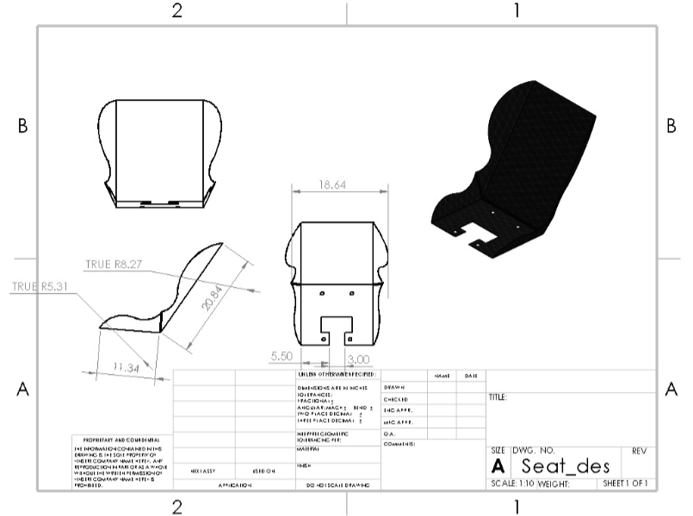
Figure 32:

Ryan Meger – PVC Prototype
The PVC prototype was a 1 to 1 scale PVC and duct tape model of the chassis. Having this type of prototype will serve to test improvement of ergonomics and ensuring the SAE Formula cockpit templates fit into our chassis. To improve ergonomics compared to last year’s design, the front hoop was moved 3 inches back and 3 inches up. This would provide easier access to the steering wheel and instruments, while also providing more leg room for the driver. Given the car must adhere to the rulebook, two templates are required to fit inside the cockpit and front hoop area. The team must check the templates fit to pass technical inspection.
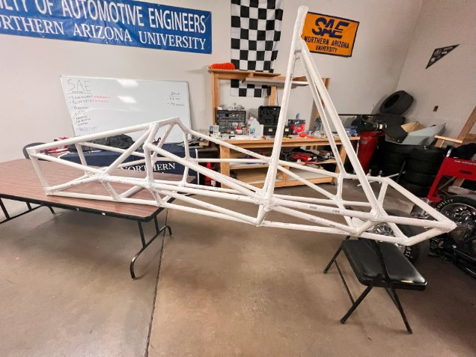
Figure 33: PVC Prototype
Once we were done with the prototype, the cockpit area visually looked bigger. We all sat inside the prototype, and all say improvements in elbow room and leg room near the front hoop. Next, we cut out the templates to the require dimensions and found both fit comfortably inside the prototype. Images below show the template compliance. The new design of the chassis informed the team the chassis design improved over last year ergonomics and would pass the technical inspection.
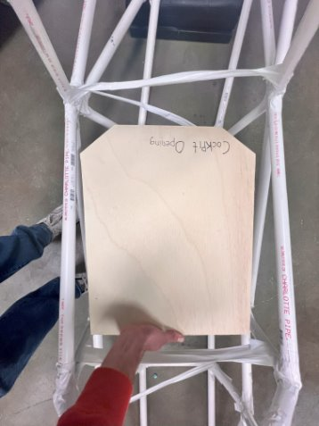
Figure 34: Cockpit Opening Template
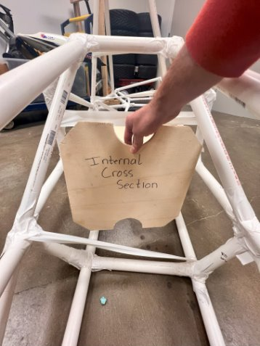
Figure 35: Internal Cross Section Template

Gustavo Ruiz – Tube Templates for Notching Prototype
The team developed a prototype process for creating tube notching templates to improve the efficiency and accuracy of building the chassis for the FSAE car. Although it required extra time to design and apply the templates to each tube, this approach ensured precise cuts and an organized manufacturing process.
Using SolidWorks, I isolated individual frame members from the chassis design, as shown in Figure 36, where a tube in the frame is highlighted and made into its own part. I then added a thin line to the front profile of each tube and used an extruded cut to represent the notch. The Sheet Metal flattening tool was used to create flat templates that could wrap around the tubes. These templates were turned into drawings, as seen in Figure 37, where the tube is shown in the flattened sheet metal feature.
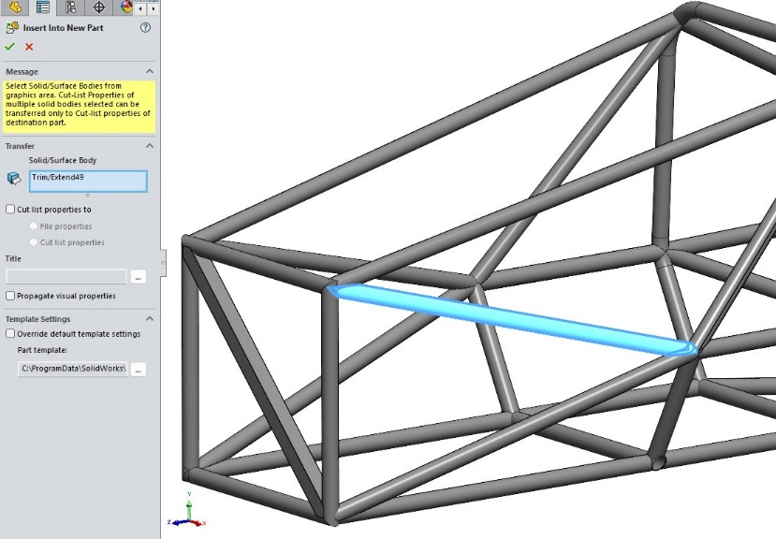
Figure 36: Insert Into New Part Feature on SolidWorks
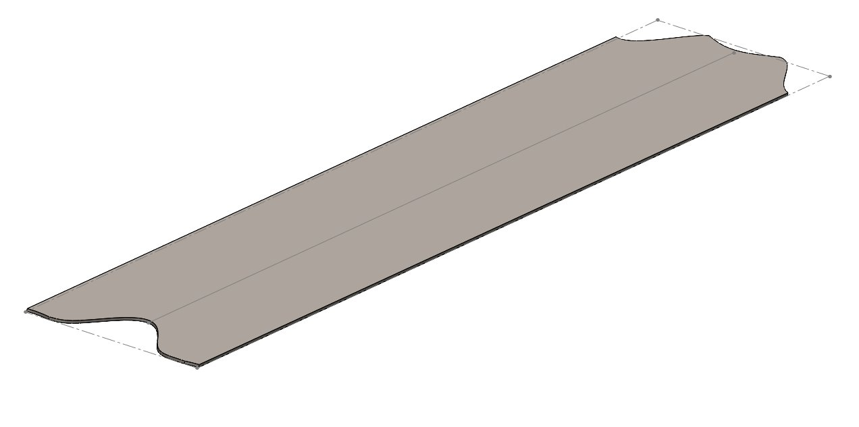
Figure 37: Flattened Tube for Template
Initially, the templates didn't match the tube's circumference because the K-factor was set to 0.5 instead of 1. After adjusting the K-factor, the templates matched the calculated circumference of a 1-inch tube (3.14 inches). I also used SolidWorks’ Trim and Extend tool to modify the tube ends based on how they connected at nodes.
The process involved cutting the tubes to length, marking centerlines for alignment, and wrapping the templates around them. As shown in Figure 38, the tube template is taped onto the tube with a centerline for reference. The templates were traced with markers to create durable guidelines for notching. The completed tubes were then checked for fitment in the jig, which the welder confirmed was accurate.
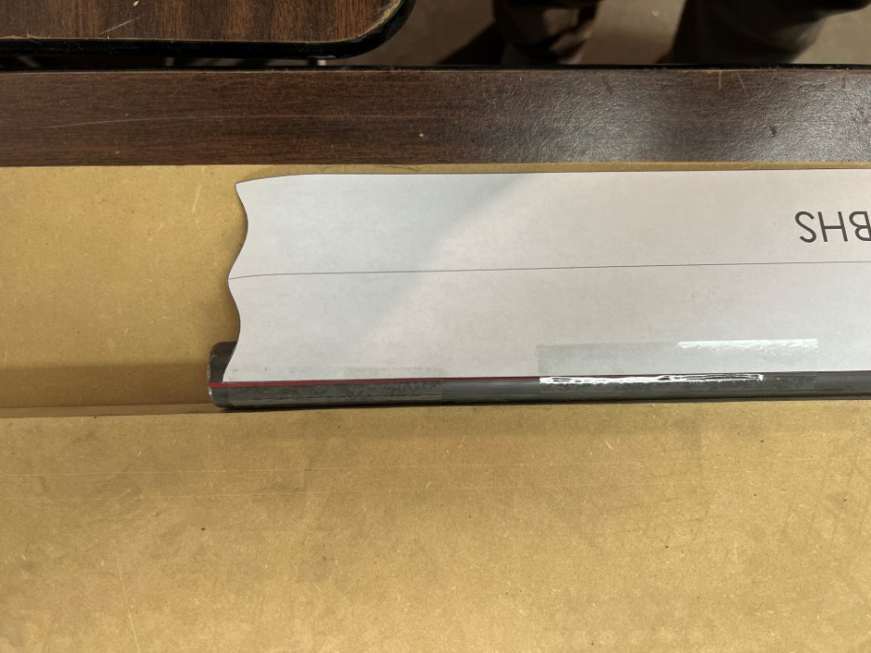
Figure 38: Tube Template Applied to Tube

Gustavo Ruiz – JIG Design Prototype
The chassis jig was designed to hold the frame at specific angles for welding or tacking. The jig included eight planes made of MDF boards, which were strategically placed between sections with angled tubes to ensure proper alignment and accessibility for welding. Each section plane was spaced to accommodate the tubes while leaving room for the welder to work, although some parts were tight. As the welding progressed, certain MDF sections were removed to allow access to different areas.
To create the jig, I used SolidWorks to design the section planes, ensuring they were properly spaced between the front bulkhead, front hoop, and front suspension box. The challenge with angled tubes was that they intersected the planes as ellipses, not perfect circles. To address this, I used the "Convert Entities" tool to create accurate intersections for the tube shapes. I then designed cutout templates for each section, ensuring they were wide enough to fit the tubes snugly but not obstruct their path. Figure 39 shows the first MDF cutout sketch for the first section and first plane.
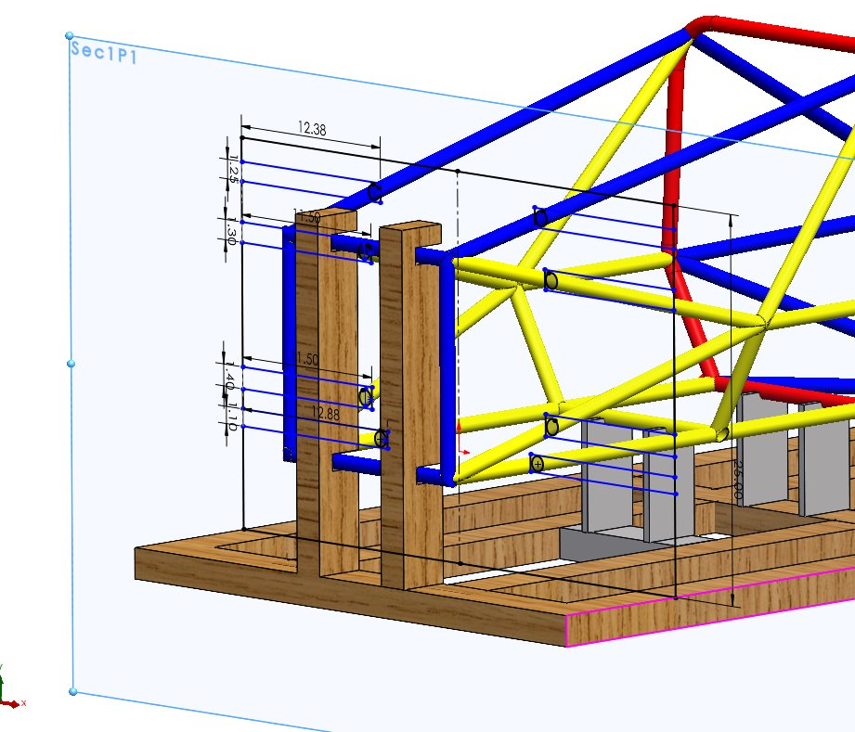
Figure 39: 1st MDF Sketch on 1st Plane of 1st Section
During the process, adjustments were made to the cutouts to prevent interference with the tubes, especially as the MDF boards were ¾ inch thick. The final design was mirrored to maintain symmetry, and the CAD files were used to cut the MDF boards to size. Additionally, modifications were planned for the front bulkhead area to accommodate the anti-intrusion plate support. Figure 40 provides a side view of the tube entering the MDF board to ensure the tube does not intersect with the thickness of the MDF.
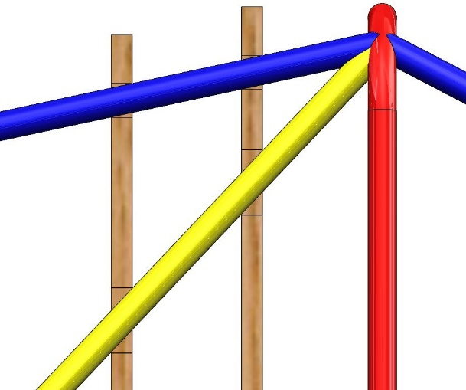
Figure 40: Side View of MDF Board w/ Respect to Tube
The completed jig design provided the necessary structural foundation for accurately welding the chassis components together. Figure 41 displays the completed jig with the frame, featuring transparent MDF boards for better viewing.
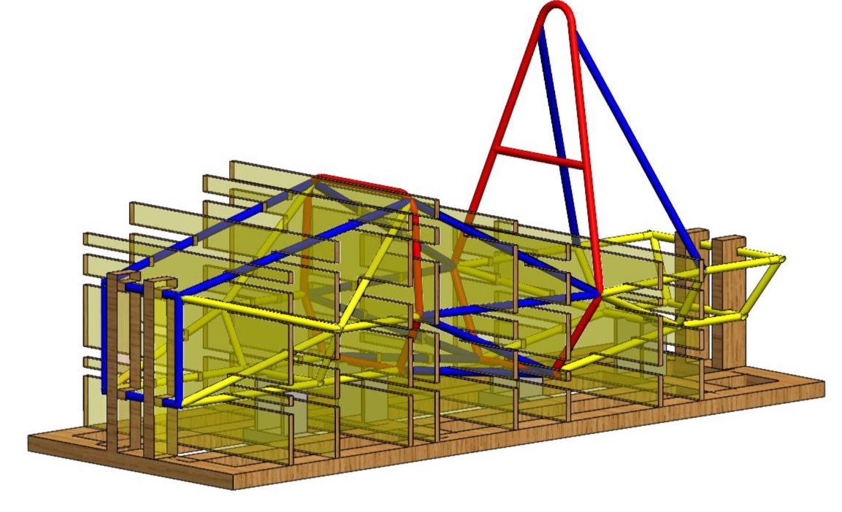
Figure 41: JIG Design

Gustavo Ruiz – Front Bulkhead Prototype
The front bulkhead is a critical part of the car’s frame, designed to protect the driver's feet. It is made from size B tubing, with 45° angle cuts on all four sides instead of bending the tubes, as bending was difficult to control. A chop saw was used to make these cuts. The bulkhead also includes a size D square tube running diagonally for the anti-intrusion plate support. To ensure accurate cuts, we created a template for the square tube instead of eyeballing it. Figure 42 shows the cutout template for the anti-intrusion plate applied to the square tube.
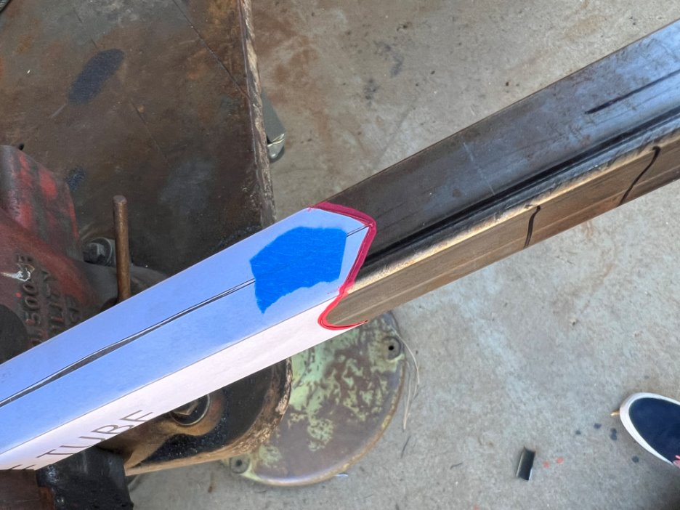
Figure 42: Anti-Intrusion Plate Support Cutout Applied
During the fitting process, we had to grind the inner corners of the bulkhead members to reduce gaps and make welding easier. Once the fit was correct, we tacked the pieces together and then welded them fully, establishing a solid reference for the front hoop and other parts of the frame. We also learned that using a template for the 45° cuts would have provided more accuracy and saved time compared to relying on the chop saw alone. Figure 43 shows the completed welded front bulkhead.
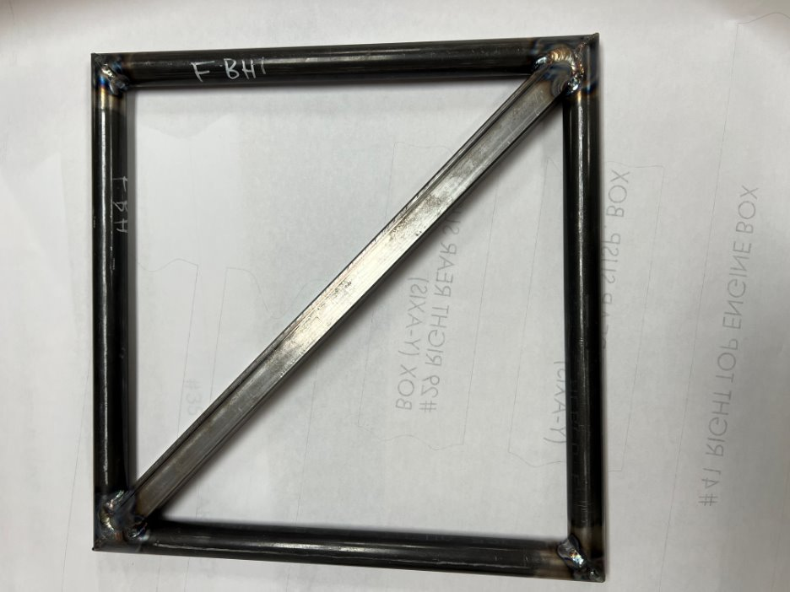
Figure 43: Front Bulkhead

Gustavo Ruiz – Frame Cut list Prototype
The frame with the cut list prototype helped us ensure the efficient and accurate fabrication of the chassis with minimal errors in cutting, assembly, and welding. By using the frame cut list along with a balloon diagram, we organized a material inventory that outlined how much tubing of each size was needed, as well as what had been used or cut. This allowed us to determine the exact length to cut each tube, such as item number 10, the left lower side impact structure, which needed to be 26.7 inches long. Having this precise information also helped us plan tube notching by giving us extra length for adjustments.
The cut list also streamlined our tube preparation process. By organizing the cuts in sequence from front to back, we could plan which parts needed notching first and ensure no misalignment of the tubes. Additionally, the frame cut list was crucial for designing the jig, as it helped define tube positions and ensured accurate dimensions to avoid interference with the MDF board. This approach minimized trial and error and accelerated the chassis assembly process, especially in preparing the front components. Figure 44 will show the frame with a balloon diagram aligned with the cut list for further clarity.
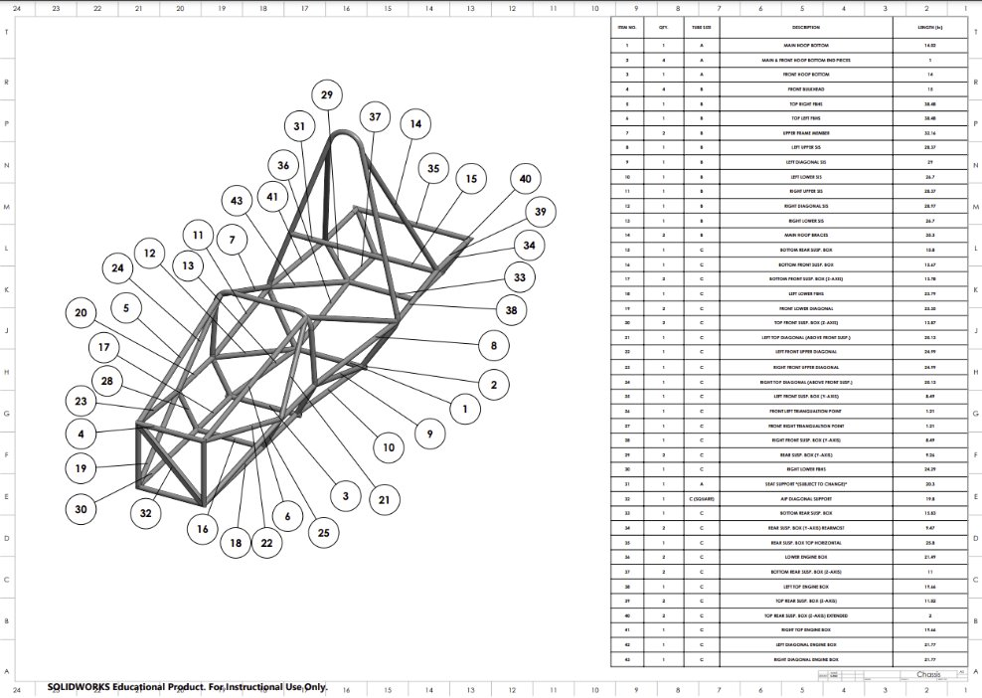
Figure 44: Frame w/ Cut List
Brandon Guzman – Firewall Prototype:
Defined below is the first iterations of the firewall design for the 2025 car. It is important to note that this design is subject to change as the placement of many components has not been finalized. The goal is to design a firewall that can prevent any component the driver touches from exceeding 60$°C$[12b], the mathematical analysis for the radiation emitted from the exhaust will be defined in section 6.3. The firewall will be constructed of aluminum sheet metal that has been polished to reflect radiation heat transfer from the exhaust behind the driver seat, this material was selected because polished aluminum reflects 85-90% of radiation heat. Prototyping firewall designs will allow for a theoretical thermal resistive network to be created for the aluminum sheet acting as a radiation shield.
Using SolidWorks assembly, the first iterations of these prototypes were brought to life for visual simplicity. Included in the figure below is the firewall design fitted onto the chassis using Dzus fasteners, these fitting will allow the firewall to be removable and were selected because of their strong resistance to vibration.
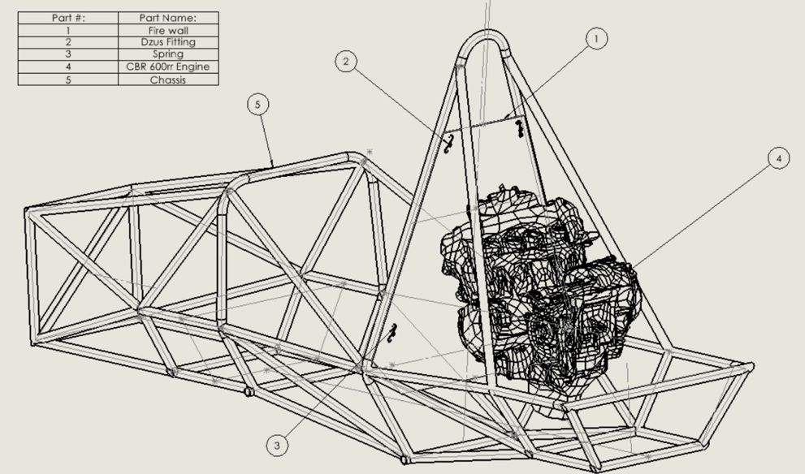
Figure 45: First iteration of firewall design
The iteration in Figure 45 is a first prototype created before the drivetrain sub-team had finalized the positioning of the exhaust. The next figure below is a more up to date version of the firewall design, but once again it is subject to change as the seat and fuel tank placement have not been finalized. Once the placement of these components has been finalized, the current design will be iterated on to be built around the placement of these much more important components, these designs act as proof of concept.
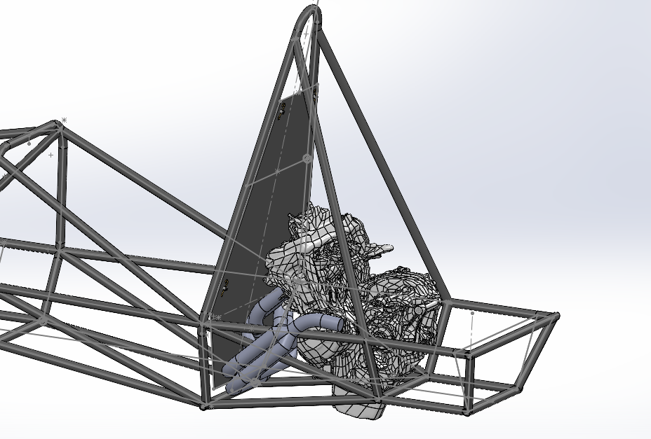
Figure 46: Firewall design with Engine and Exhaust

Carson Kent – Front Wing and Nose Cone Prototype
In the images below, are the first iterations of the nose cone and front wing assembly for the car. The goal of this prototype is to create something that can be tested and iterated upon before coming to the final design. These initial designs were created in SolidWorks, and they are designed to be tested in Ansys Fluent in the near future. With this CAD model we will be able to create mounts for the separate pieces and also run aerodynamic analysis to find the amount of downforce these parts create.
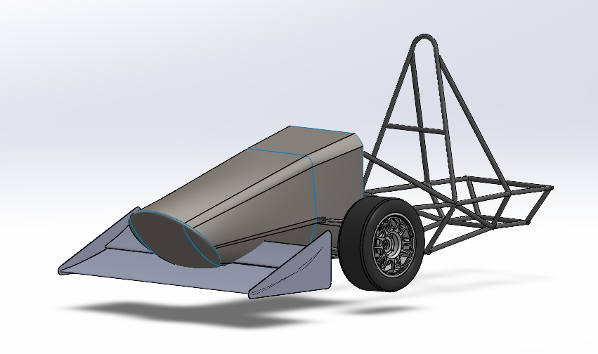
Figure 47: Current Aero Design with wheels and tires

In Figure 47 the current full assembly of the aero components is displayed. Working with the suspension team I was able to get the exact location of the wheels and the suspension geometry. However, the suspension components were removed due to ease of input for Ansys Fluent. In the next few weeks there are plans to move forward with creating a foam mold of the nose cone to get ahead on that front. With this mold we can build our carbon fiber nose cone with the help of Nova Kinetics.
One aspect of the design that I may work to change is the very front portion of the nose cone because I believe it can be more aerodynamically efficient than it is at this point. Creating the front of the nose cone was mostly dependent on my ability to close that off, however now I think I can create a more efficient design.
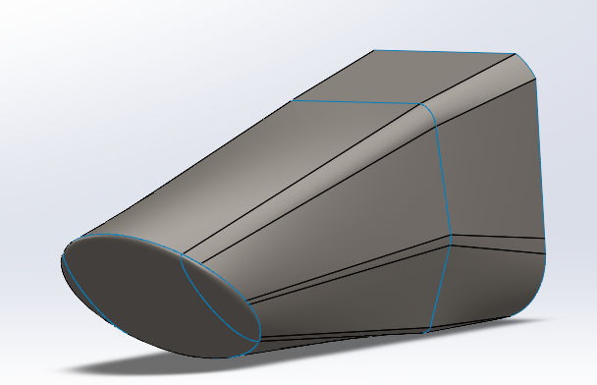
Figure 48: Front Nose Cone Current Design – Isolated
With this isolated nose cone, I will be able to create cross sectional drawings that we can print 1 to 1 on the plotter. With these drawings we will be able to perfectly cut a larger block of foam down to exact dimensions. This foam will serve as our mold prototype, which we will use to form our nose cone.

Other Engineering Calculations

Brandon Guzman – Thermal resistive network of Firewall:
The calculations below are for the heat transfer rate between the exhaust and driver seat as well as amount of radiation emitted from the exhaust using the Stephan Boltzmann equation.
Terms:
- $ϵ_{1}=$Emissivity of exhaust material [304 Stainless Steel] which is 0.36-0.44 [9b]
- $A_{1}=$Estimate of Surface area of exhaust facing fire wall [$m^{2}$] which is 0.0387096$m^{2}$
- $F_{1s \& 2s} =$ shape factor and is assumed to be 1, since material chosen for firewall is aluminum and polished aluminum reflects 85-90% of radiation we can Assume the shape factor to be 1 since the two surfaces are parallel to one another.
- $ϵ_{s1 \& s2}=$Emissivity of Fire wall (Polished aluminum) which is 0.05-0.10 [9b]
- $A_{s}=$Surface area of fire wall [$m^{2}]$ which is 0.4362$m^{2}$ in total, Portion facing exhaust is 0.13837$m^{2}$
- $A_{2}=$Surface area of back of seat [$m^{2}]$ which is 0.2958$m^{2}$
- $ϵ_{2}=$Emissivity of seat (Carbon Fiber) which is 0.3-0.5 [10b]
- $q=$Heat Transfer rate [W]
- $σ=Stephan Boltzman constant$ [$\frac{W}{m^{2}*K^{4}}]$ which is 5.67 x ${10}^{-8}\frac{W}{m^{2}*K^{4}}$
- $T_{1}=$Exhaust Temperature [$°K$]
- $T_{2}=$Seat Temperature [$°K$], Assumed to be ambient temperature which is 293.15 [$°K$]

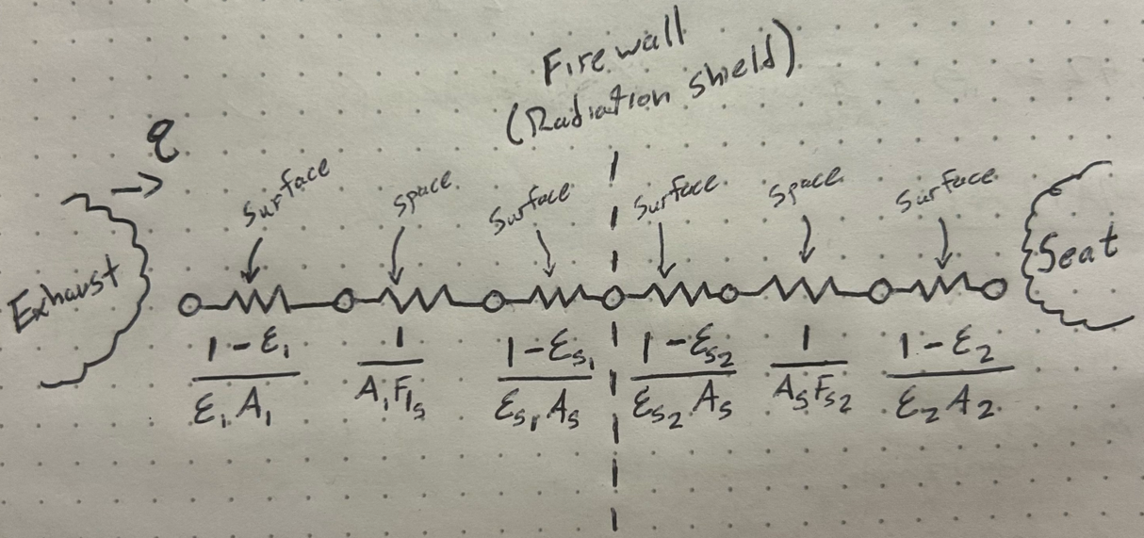
Figure 46: Theoretical Thermal Resistive network of firewall
The Equation for Heat Transfer rate for this problem is defined below, this will be used to estimate heat transfer rate between the two surfaces[11b]:

$$q= \frac{σ(T_{1}^{4}-T_{2}^{4})}{\frac{1-ϵ_{1}}{ϵ_{1}A_{1}}+ \frac{1}{A_{1}F_{s1}}+\frac{1-ϵ_{s1}}{ϵ_{s1}A_{s}}+\frac{1-ϵ_{s2}}{ϵ_{s2}A_{s}}+\frac{1}{A_{s}F_{s2}}+\frac{1-ϵ_{2}}{ϵ_{2}A_{2}}} (1)$$

$$q_{moving}= \frac{(5.67×{10}^{-8}\frac{W}{m^{2}*K^{4}})({810.93}^{4}-{293.15}^{4})°K}{\frac{1-0.4}{0.4(0.03871m^{2})}+ \frac{1}{(0.03871m^{2})(1)}+\frac{1-0.07}{0.07(0.4362m^{2})}+\frac{1-0.10}{0.10(0.4362m^{2})}+\frac{1}{0.4362m^{2}(1)}+\frac{1-0.4}{0.4(0.2958m^{2})}}$$

$q_{moving}=$195.88 [W]

$$q_{Idling}= \frac{(5.67×{10}^{-8}\frac{W}{m^{2}*K^{4}})({644.26}^{4}-{293.15}^{4})°K}{\frac{1-0.4}{0.4(0.03871m^{2})}+ \frac{1}{(0.03871m^{2})(1)}+\frac{1-0.07}{0.07(0.4362m^{2})}+\frac{1-0.10}{0.10(0.4362m^{2})}+\frac{1}{0.4362m^{2}(1)}+\frac{1-0.4}{0.4(0.2958m^{2})}}$$

$$q_{Idling}=75.99 [W]$$

The Stephan Boltzmann equation will then be used to estimate radiation emitted from the exhaust:

$E= εσA_{s}T^{4}$ (2)

Absolute Temperature of exhaust while moving = 1000 $°F$ or 810.93$°K$

$$E_{Moving}=(0.4)(5.67×{10}^{-8}\frac{W}{m^{2}*{°K}^{4}})(0.4362m^{2})({810.93}^{4}°K)$$

$$E_{Moving}=4278.21[W]$$

Absolute temperature while idling = 700 $°F$ or 644.26 $°K$

$$E_{Moving}=(0.4)(5.67×{10}^{-8}\frac{W}{m^{2}*K^{4}})(0.4362m^{2})({644.26}^{4})$$

$$E_{Idling}=1704.41 [W]$$

For this theoretical analysis of the Radiation heat transfer rate between two surfaces and the radiation emitted from the exhaust while moving and idling, the results seem to be reasonable based on calculations. It is important to note that all these values are subject to change because placement of certain components and mounts have not been finalized. This analysis is meant to be a proof of concept for the thermal resistive network and therefore the temperature surrounding the seat/cockpit will not be solved until further confirmation of exhaust temperature and firewall dimensions have been adjusted to best fit other sub teams deliverables.

Future Testing Potential
The chart in the Figure below highlights significant failure points from components of the chassis design. In addition, the plans for controlled testing are listed to address these failure points.
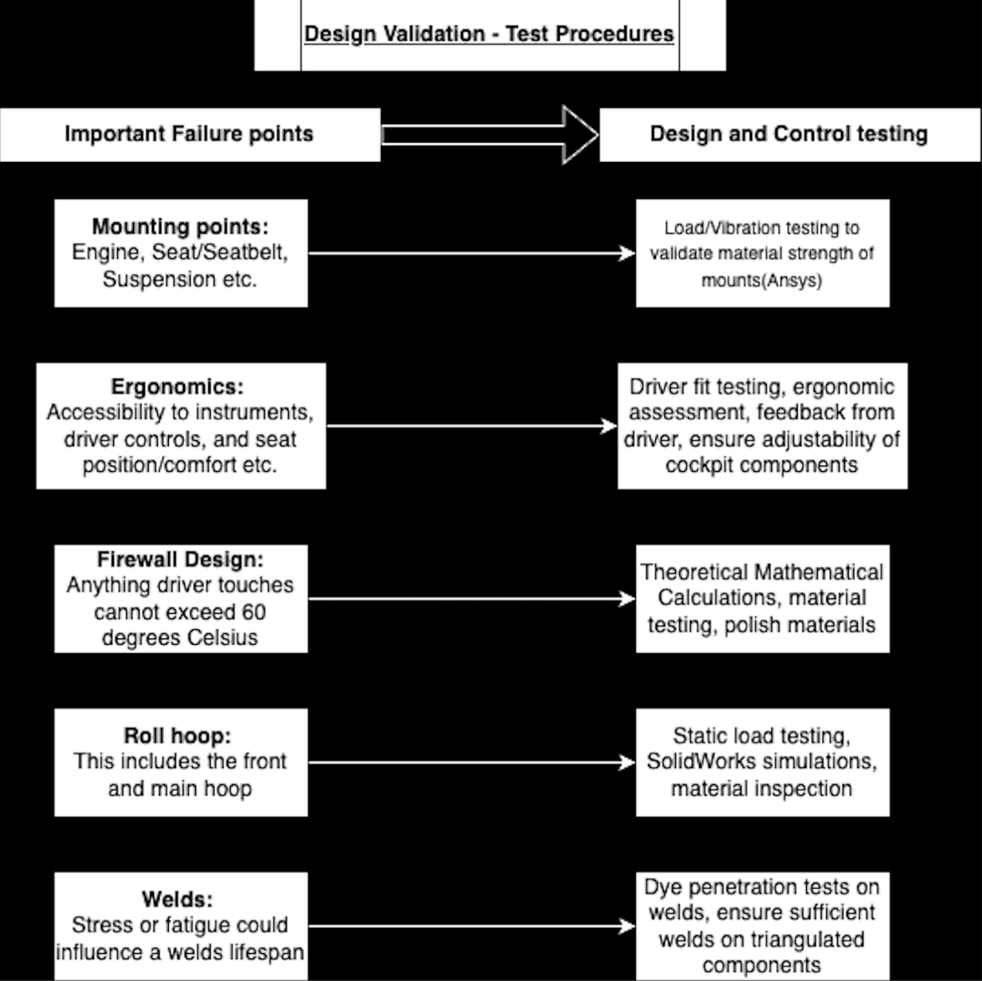
Figure 47: Testing plans

REFERENCES

Alexandra Brister
[1a] Bruno Muss. "Crash test numerical analysis of a Formula SAE vehicle," YouTube, 1/17/2018. https://www.youtube.com/watch?v=c8k9Idy5kwk
[2a] C. D. Carter, C. B. Sherman, and R. D. Matthews, “Design of a Formula SAE race car: Vehicle Dynamics and Performance,” SAE Technical Paper Series, Feb. 1982. doi:10.4271/821092 Aerodynamics
[3a] C. Itu, A. Toderita, L.-V. Melnic, and S. Vlase, “Effects of seat belts and shock absorbers on the safety of racing car drivers,” Mathematics, vol. 10, no. 19, p. 3593, Oct. 2022. doi:10.3390/math10193593
[4a] The, Dynamics: Force and Newton’s Laws of Motion. 2019 (Chapter 4).
[5a] K. Baszczyński and M. Jachowicz, “The Effect of the Use of Full Body Harnesses on Their Protective Properties,” International Journal of Occupational Safety and Ergonomics, vol. 15, no. 4, pp. 435–446, Jan. 2009, doi: https://doi.org/10.1080/10803548.2009.11076823.
[6a] R. G. Budynas, J. K. Nisbett, and J. E. Shigley, Shigley’s mechanical engineering design. New York, NY: McGraw-Hill Education, 2020. Chapter 3
[7a] “SAE standards for Mobility Knowledge and Solutions,” SAE International, https://www.sae.org/standards?utm_source=google&utm_medium=ppc&utm_campaign=LVL_SAE_SCH_GSE_NTN_GPM_B2C_Standards&utm_content=Standards&utm_term=B2C&utm_device=c&utm_keymatch=p&utm_adposition=&gad_source=1&gclid=CjwKCAjw0aS3BhA3EiwAKaD2ZSgsuuN9rfyeBQE_uWePei2JlxfRiqc2r97IeRPudAJ_66PtXDuT6xoC7T4QAvD_BwE (accessed Sep. 17, 2024).
[8a] B. Herbstreit, “Seat & Firewall Design for Cornell Racing FSAE,” Dec. 2017. Available: https://www.ergofoundation.org/images/Bailey_Herbstreit_%20Seat_and_Firewall.pdf
[9a] H. Bergstrand, “F-SAE Race Car Seat Design -A user-centred concept development project.” Accessed: Nov. 27, 2024. [Online]. Available: https://hampusbergstrand.com/wp-content/uploads/2017/02/F-SAE_race_car_seat_design_Hampus_Bergstrand_2015_Newcastle.pdf
[10a] M. Scheitlin and T. Bräunl, “Renewable Energy Vehicle Project: Pedal Box Design for Formula SAE,” 2011. Available: https://robotics.ee.uwa.edu.au/theses/2011-REV-3-PedalBox-Scheitlin.pdf

Ryan Meger
[1r] A. Castrillion, G. Contreras, and A. Martinez, Modeling of a chassis for an SAE formula car, http://www.irphouse.com/ijert21/ijertv14n10_10.pdf (accessed Oct. 21, 2024).
[2r] SolidWorks, “SolidWorks FSAE & Formula Student Tutorials,” YouTube, https://www.youtube.com/playlist?list=PL38088C14E31FAF31 (accessed Oct. 20, 2024).
[3r] C. Dodd, C. Morris, P. Geneva, and N. Geneva, Meeg 402-010 chassis design report 2017 FSAE SENIOR ..., https://udel.edu/~pgeneva/downloads/fsae/2017_FSAE_chassis.pdf (accessed Oct. 21, 2024).
[4r] N. Vishal and S. Aditya, Analysis of FSAE chassis - IJSER, https://www.ijser.org/researchpaper/ANALYSIS-OF-FSAE-CHASSIS.pdf (accessed Oct. 21, 2024).
[5r] CAD CAM tutorial by Mahtabalam, “Solidworks simulation,” YouTube, https://www.youtube.com/playlist?list=PLRhna5_X7uWt2LF-ZiuXFt5jrubF32C94 (accessed Oct. 20, 2024).
[6r] V. Chikkali and R. Patil, FEA analysis of FSAE chassis, https://www.ijert.org/research/fea-analysis-of-fsae-chassis-IJERTV9IS070148.pdf (accessed Oct. 21, 2024).
[7r] D. Krzikalla, J. Mesicek, J. Petru, A. Sliva, and J. Smiraus, “Analysis of torsional stiffness of the frame of a formula student vehicle,” Journal of Applied Mechanical Engineering, vol. 08, no. 01, 2019. doi:10.35248/2168-9873.19.8.315
[8r] W. F. Milliken and D. L. Milliken, Race Car Vehicle Dynamics William F. Milliken; Douglas L. Milliken. Warrendale, Pa: Society of Automotive Engineers, 1995. \
[9r] DIYguru, “DFMEA Explained | Automobile Engineering | BAJA / SUPRA / FSAE,” YouTube, https://www.youtube.com/watch?v=emH6JFqpj3w (accessed Nov. 26, 2024).
[10r] PTC, PTC help center, https://support.ptc.com/help/wrr/r12.0.0.0/en/index.html#page/wrr/GettingStartedGuide/FMEA/CalculationsFMEA.html (accessed Nov. 26, 2024).

Brandon Guzman
[1b] M. Planchard, “San Diego state university formula SAE team showcased at Solidworks World,” SOLIDWORKS Education Blog, https://blogs.solidworks.com/teacher/2014/01/san-diego-state-university-formula-sae-team-showcased-at-solidworks-world.html
[2b] C. Dodd, N. Geneva, P. Geneva, and C. Morris, Dr. Steven Timmins , rep., 2017 ​
[3b] “Purdue Formula SAE scores 2nd place; Best Design Score in their history,” Mechanical Engineering - Purdue University, https://engineering.purdue.edu/ME/News/2021/purdue-formula-sae-scores-2nd-place-best-presentation-score-in-their-history-
[4b] William F Milliken and Douglas L Milliken. Race car vehicle dynamics. Vol. 400. Society of Automotive Engineers Warrendale, 1995​
[5b] Martin Meywerk. Vehicle Dynamics. John Wiley & Sons, 2015​
[6b] “The construction Process: Pipe and Tube bending,” https://www.herl.pitt.edu/indiachair/indiachairsh/cl_bend.html#:~:text=Rule%20for%2090%20degree%20and%20180%20degree%20Bends&text=180%20degree%20bends%3A%20Multiply%20the,length%20of%20the%20curved%20section.
[7b] “Mastering small tube bends,” YouTube, https://youtu.be/MymUqxuCKv4?si=pWnrkCMSN0BtZO4K
[8b] “TFS: Tube Bending Basics 1 - What You Need to Know,” YouTube, https://youtu.be/3n_lf2RHIPs?si=NaGZuH7i3eOT0MqW
[9b] ennologic, Ed., “Emissivity table for infrared thermometer readings,” Emissivity Table for Infrared Thermometer Readings, https://ennologic.com/wp-content/uploads/2018/07/Ultimate-Emissivity-Table.pdf (accessed Nov. 21, 2024).

[10b] F. Wang, L. Cheng, Q. Zhang, and L. Zhang, “Effects of heat treatment and coatings on the infrared emissivity properties of carbon fibers: Journal of Materials Research,” Cambridge Core, https://www.cambridge.org/core/journals/journal-of-materials-research/article/abs/effects-of-heat-treatment-and-coatings-on-the-infrared-emissivity-properties-of-carbon-fibers/B82F9713F9E2FD2417F7E1AA7EAFEFB3 (accessed Nov. 20, 2024).

[11b] T. L. Bergan and A. S. Lavine, “13.3.4, Two-Surface Enclosures in Series and Radiation Shields,” in Fundamentals of Heat and Mass transfer, 8th ed, John Wiley and sons, 2019, pp. 808–811

[12b] S. International, “Formula SAE Rules 2025,” 2025 formula SAE rules V.1 , https://www.fsaeonline.com/cdsweb/app/NewsItem.aspx?NewsItemID=379e4a8a-80a2-4a74-87c2-6f2de4212270 (accessed Nov. 21, 2024).

Gustavo Ruiz
[1g] "Design and Analysis of FSAE Chassis for Safe Conditions" (Paper)​
Helpful design parameters and calculations to run our design through, as well as finding vertical center of gravity methods.​

[2g] "FEA Analysis of FSAE Chassis" (Paper)​
Main goal highlighted were to decrease weight and increase torsional rigidity, helpful ANSYS simulation of stresses and torsion.​

[3g] "The Science of Vehicle Dynamics", Chapter 3 "Vehicle Model for Handling" (Book)​
Great explanation on aerodynamics in a Formula car, and goes more in depth on front and rear vertical forces​

[4g] "Fundamentals of Aerodynamics", Chapter 19 "Turbulent Boundary Layers" (Book)​
Helpful way to create turbulent modeling and find characteristics of a turbulent flow.​

[5g] "Renewable Energy Vehicle Project: Pedal Box Design for Formula SAE" (Paper)​
Future Work ideas from pedal box are to decrease weight and use an angle-mounted cylinder to decrease pedal box length, like our goal. ​

[6g] "Formula SAE Rules 2025", F- Chassis and Structural (Standard)​

[7g] M. L. Mohamad et al., “Design and static structural analysis of a race car chassis for Formula Society of Automotive Engineers (FSAE) event,” Journal of Physics: Conference Series, vol. 908, p. 012042, Oct. 2017. doi:10.1088/1742-6596/908/1/012042

[8g] The Fabricator, “Tube bending basics: How to bend tubing and Metal Pipe,” The Fabricators, https://www.thefabricator.com/thefabricator/article/tubepipefabrication/tube-bending-basics-how-to-bend-tubing-and-metal-pipe (accessed Nov. 25, 2024).

[9g] Duke FSAE, “How to model a seat in Solidworks,” Duke FSAE, https://www.dukefsae.com/single-post/2017/07/17/how-to-model-a-seat-in-solidworks (accessed Nov. 26, 2024).

[10g] Seas, “Nose Cone,” Nose cone, https://www.formula1-dictionary.net/nose_cone.html (accessed Nov. 27, 2024).

Carson Kent
[1c] S. Gupta and K. Saxena, “AERODYNAMICS ANALYSIS OF A FORMULA SAE CAR.” Available: https://repository.up.ac.za/bitstream/handle/2263/62356/Gupta_Aerodynamics_2017.pdf?sequence=1
‌ [2c] “Aerodynamics of Road Vehicles, Fifth Edition,” www.sae.org. https://www.sae.org/publications/books/content/r-430/
[3c] R. Jing, Kok Wee Chong, C. Chin, and M. R. M. Julaihi, “Aerodynamic optimisation of prototype FSAE vehicle through biomimetic approach,” vol. 72, pp. 2869–2874, Jan. 2023, doi: https://doi.org/10.1016/j.matpr.2022.07.307.
[4c] Airfoil Tools, “NACA 4 digit airfoil generator (NACA 2412 AIRFOIL),” Airfoiltools.com, 2019. http://airfoiltools.com/airfoil/naca4digit
[5c] A. Wood, “Introduction to Airfoil Aerodynamics | AeroToolbox,” AeroToolbox, Jul. 20, 2017. https://aerotoolbox.com/intro-airfoil-aerodynamics/
[6c] M. Nakamura, “How An Airfoil Works,” Mit.edu, 2019. https://web.mit.edu/2.972/www/reports/airfoil/airfoil.html
[7c] mi508668, “Chapter 5: Theory of Airfoil Lift Aerodynamics,” pressbooks.online.ucf.edu, Available: https://pressbooks.online.ucf.edu/aerodynamicstext/chapter/chapter-5-theory-of-airfoil-aerodynamics/
‌ [8c]“Aerodynamics of an FSAE Car | Ansys Innovation Courses,” Innovation Space, Apr. 17, 2024. https://innovationspace.ansys.com/product/external-aerodynamic-analysis-of-an-fsae-car/
[9c] Simple Random Knowledge, “FSAE Chassis Design with Weldments in SolidWorks | With Complete Rules Explanation | Formula Student,” YouTube, Jun. 13, 2021. https://www.youtube.com/watch?v=u--aROYyMfs (accessed Nov. 28, 2024).
[10c] I. Oxyzoglou, “(PDF) Design & Development of an Aerodynamic Package for an FSAE Race Car,” ResearchGate, May 2017. https://www.researchgate.net/publication/320556659_Design_Development_of_an_Aerodynamic_Package_for_an_FSAE_Race_Car
‌

‌

‌

APPENDICES

Appendix A: FSAE Rules
https://www.fsaeonline.com/cdsweb/app/NewsItem.aspx?NewsItemID=3c9ca3eb-471e-472f-8453-99b943840ac7

Appendix B: House of Quality

Appendix C: FMEA
